<https://www.youtube.com/watch?v=CqLGvwi-5Pc&list=PLblh5JKOoLUIzaEkCLIUxQFjPIlapw8nU&index=6>

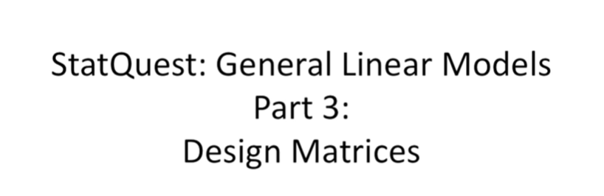

Hello and welcome to stat quest.

Stat quest is brought to you by the friendly folks in the genetics department at the University of North Carolina at Chapel Hill.

Today we're going to be talking about general linear models and this is part 3 of a series that we're doing on this.

This time we're gonna focus on design matrices.

This stat quest picks up exactly where part two leaves off.

So if you haven't seen that one yet I'd recommend doing it right now.

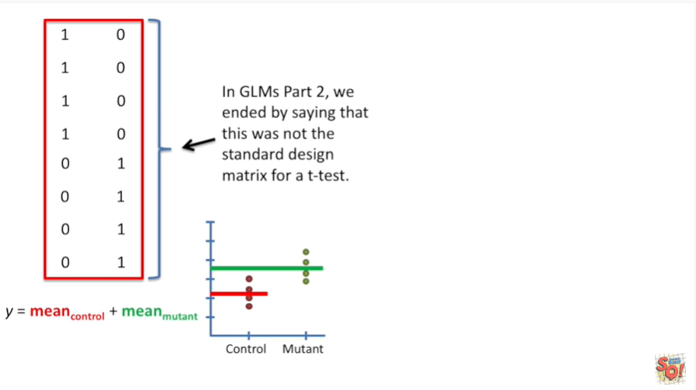

In part two of this series we ended by saying that this was not the standard design matrix for a t-test.

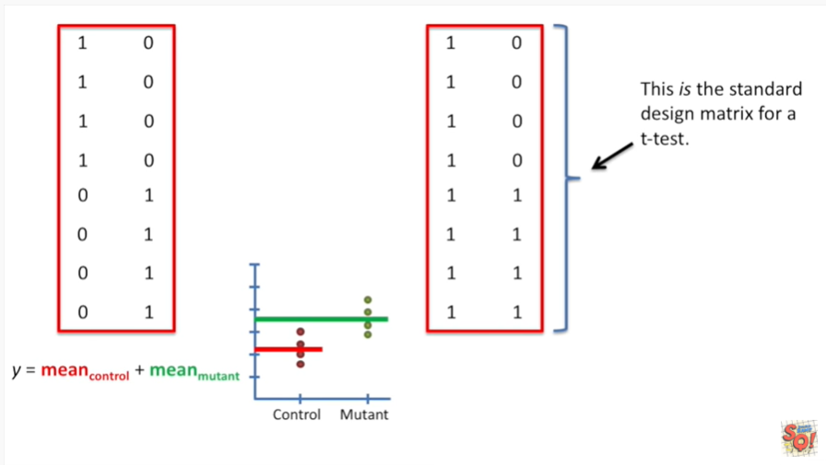

It was kind of a cliffhanger.

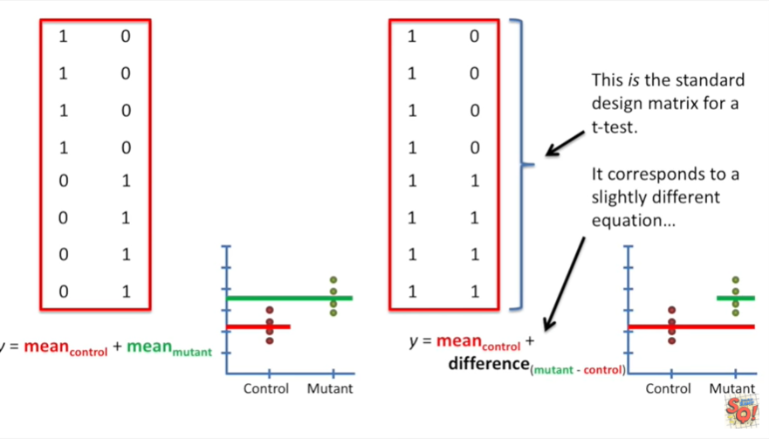

And then I showed you that this is the standard design matrix for a t-test it corresponds to a slightly different equation.

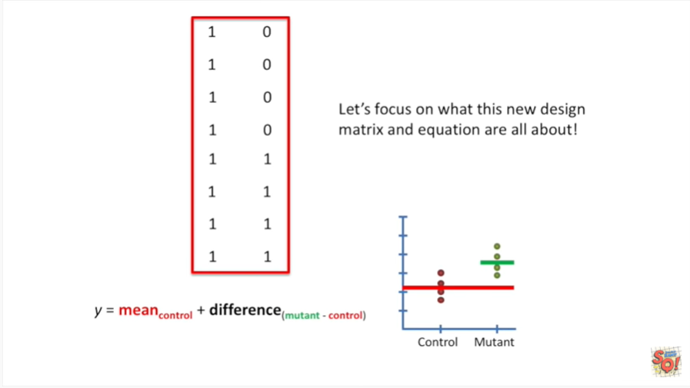

Let's focus on what this new design matrix and equation are all about.

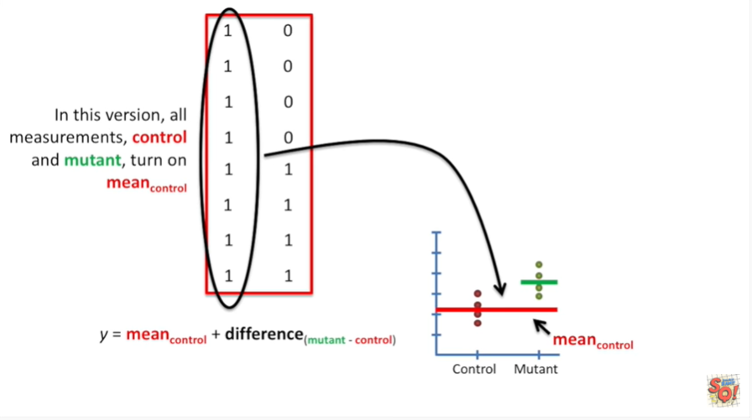

In this version all measurements both control and mutant turn on the term for the mean control value.

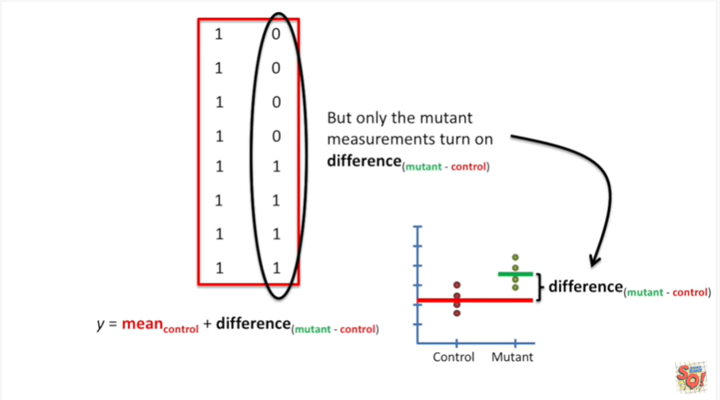

But only the mutant measurements turn on the term for the difference between the mean of the mutant data and the mean of the control data.

This term serves as an offset that we can use for the mutant data.

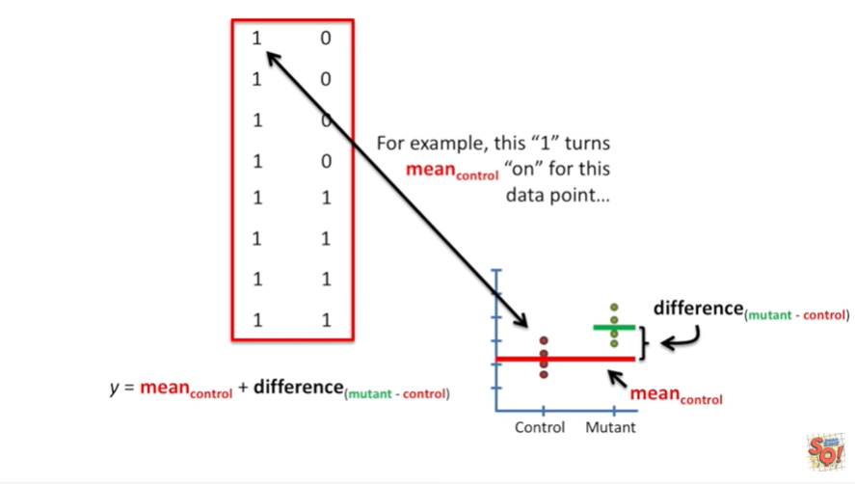

For example this one turns the term for the mean of the control data on for this data point.

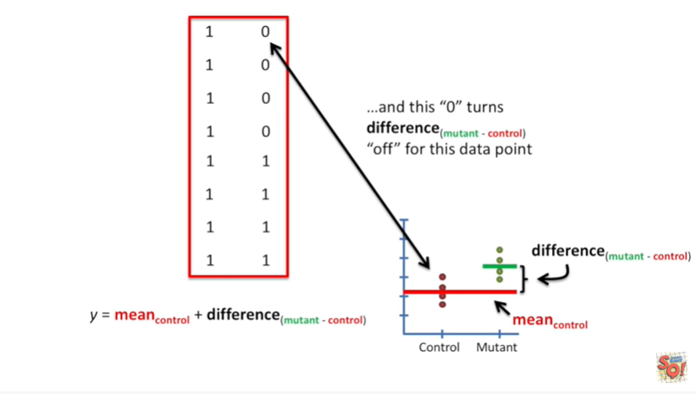

And this zero turns the term for the difference between the mean of the mutant data and the mean of the control data off for this data point.

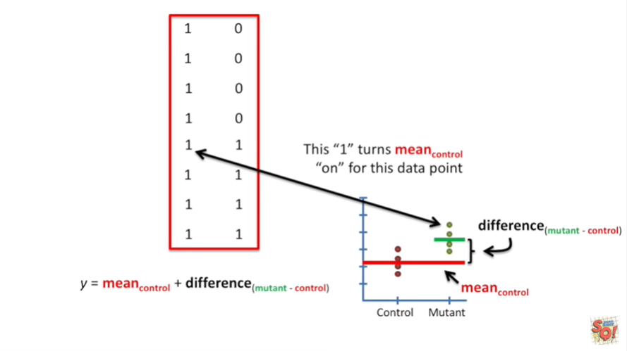

This one turns the term for the mean of the control data on for this data point.

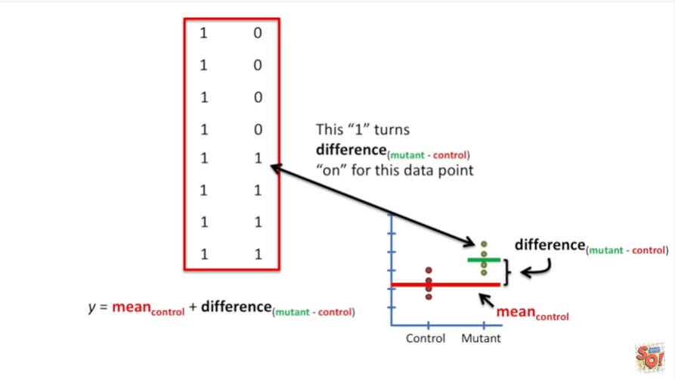

And this one turns the term for the difference between the mean of the mutant data and the control data on for this data point.

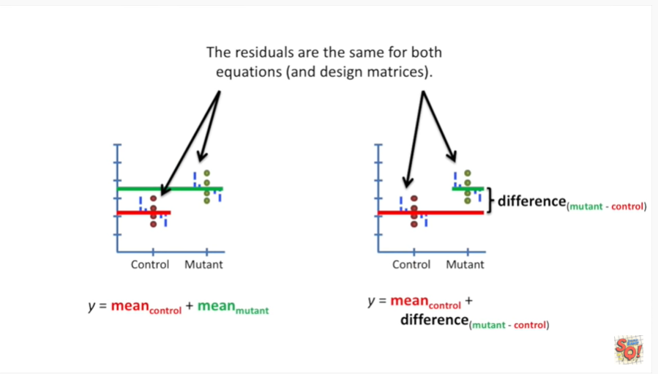

The residuals are the same for both equations and design matrices.

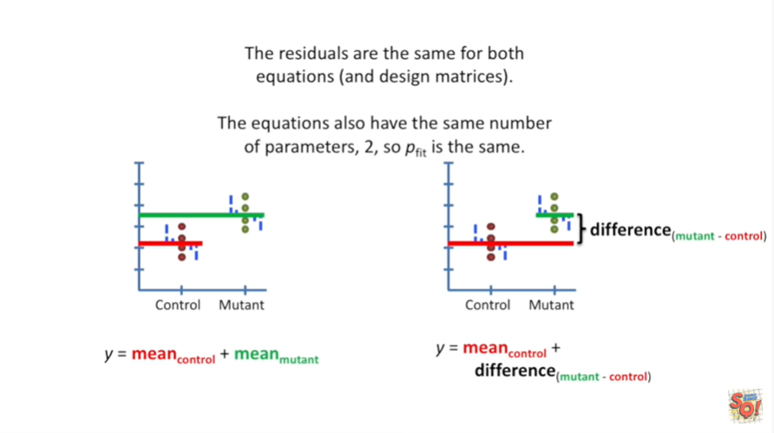

The equations also have the same number of parameters too.

So P fit is the same.

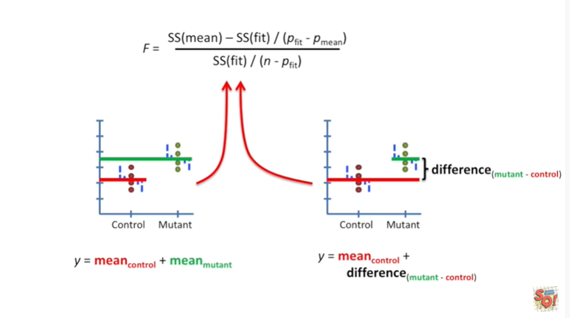

So in our equation for f we plug in the exact same value for the sum of squares around the fit.

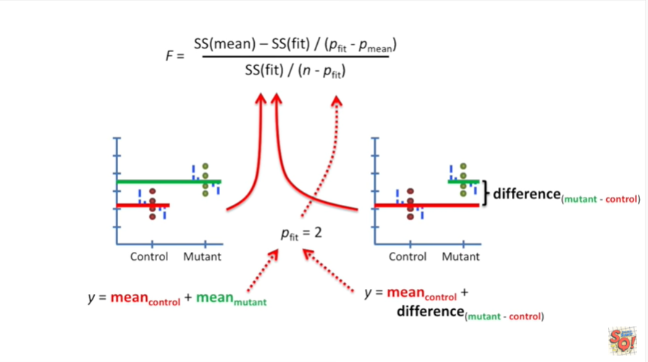

We also plug in the exact same value for the P fit parameter.

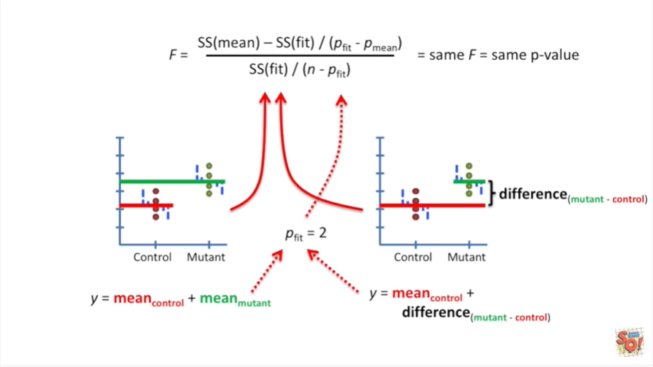

This results in the exact same value for F and that means we're going to get the exact same P value.

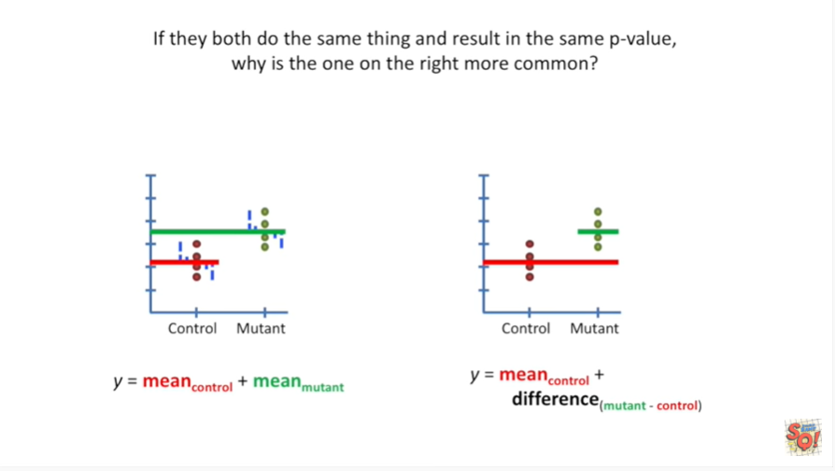

If they both do the same thing and the result is the same P value Y is the one on the right more common.

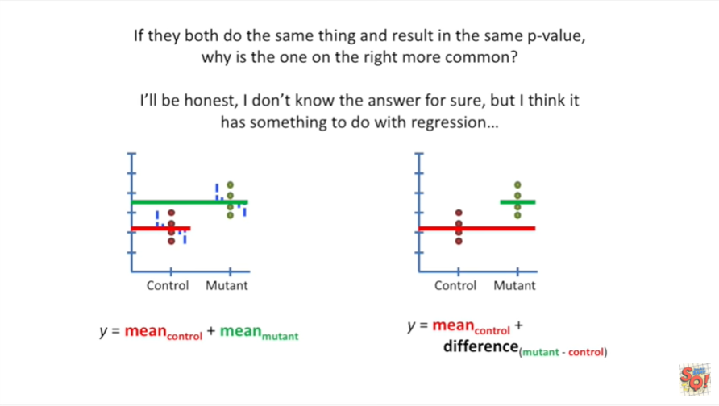

I'll be honest I don't know the answer for sure.

But I think it has something to do with regression.

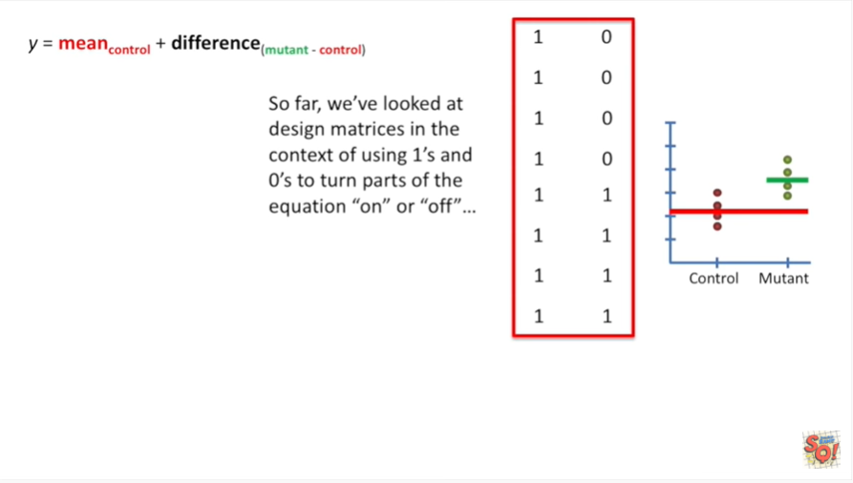

So far we've looked at design matrices in the context of using ones and zeros to turn parts of the equation on or off.

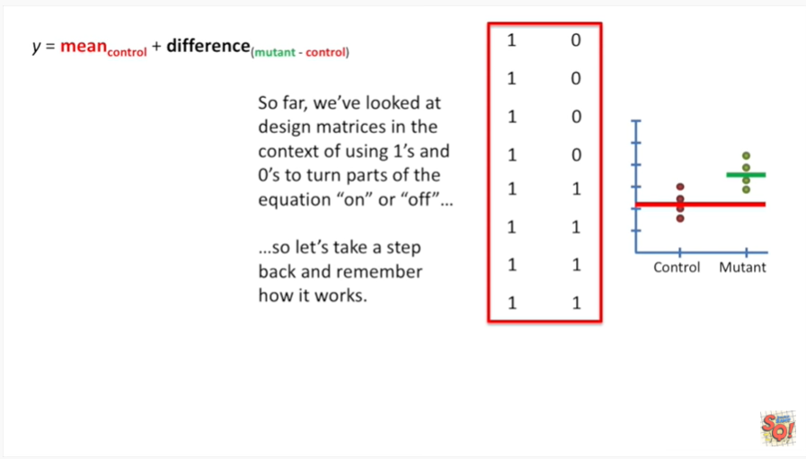

So let's take a step back and remember how it works.

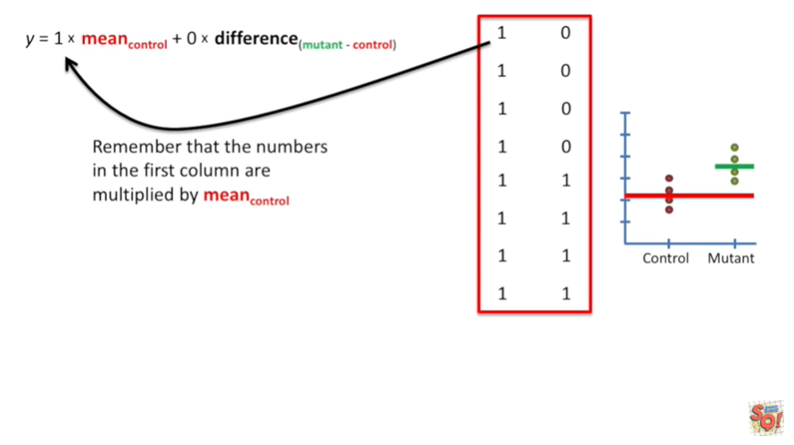

Remember that the numbers in the first column are multiplied by the term for the mean of the control values.

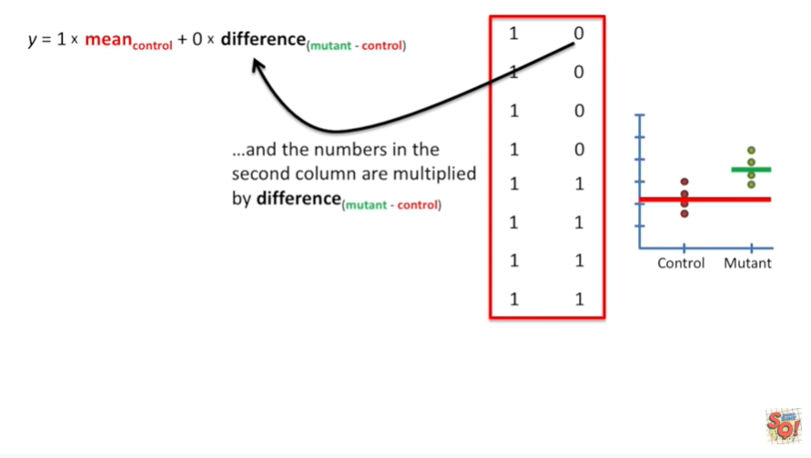

And the numbers in the second column are multiplied by the term that represents the difference between the mean of the mutant values and the mean of the control values.

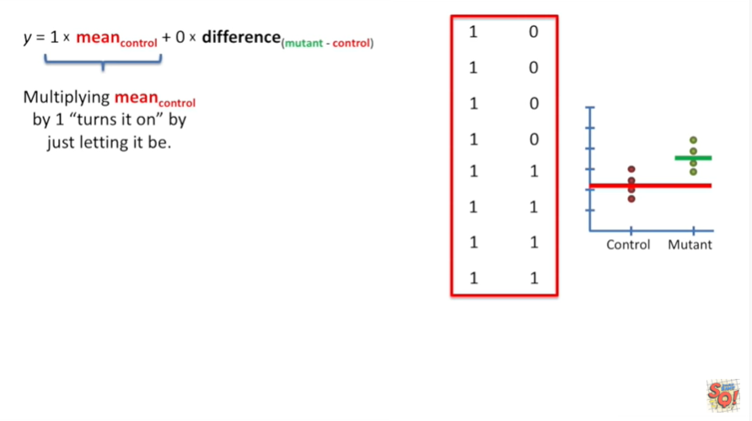

Multiplying the mean of the control data by one turns it on by just letting it be.

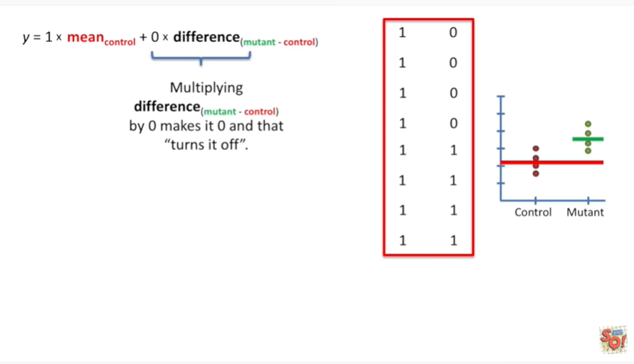

Multiplying the difference between the mean of the mutant data and the mean of the control data by zero makes it zero and that turns it off.

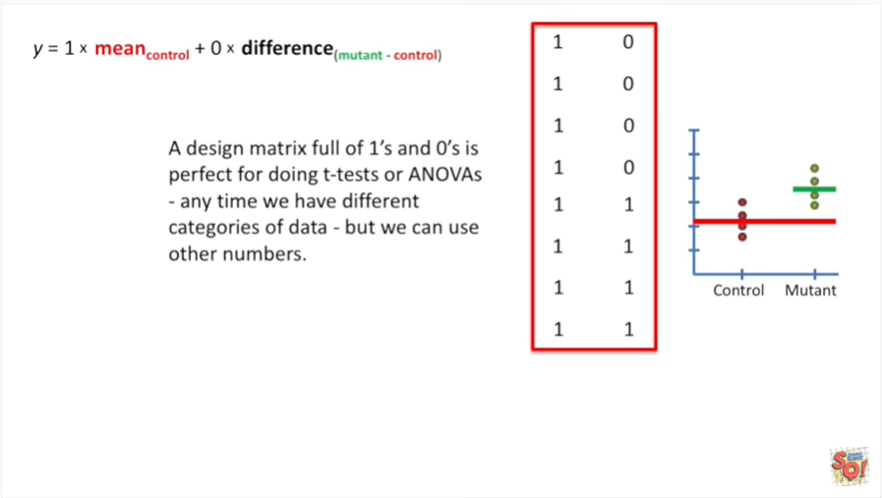

A design matrix full of ones and zeros is perfect for doing T tests or ANOVA's.

Anytime we have different categories of data but we can use other numbers.

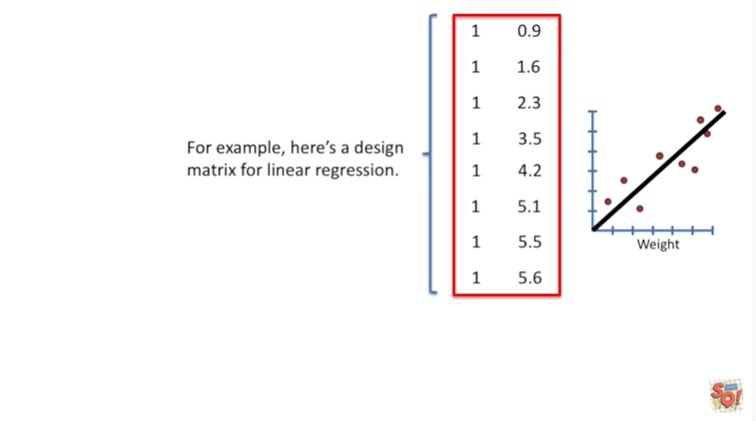

For example here's a design matrix for linear regression.

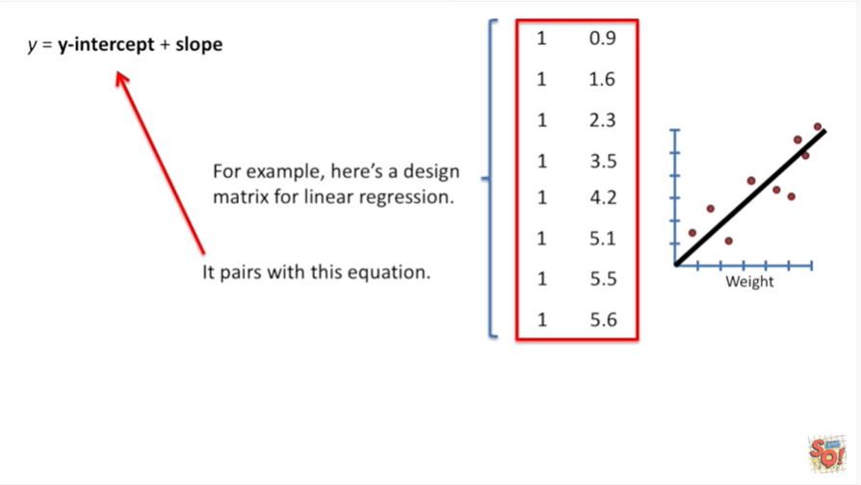

It pairs with this equation.

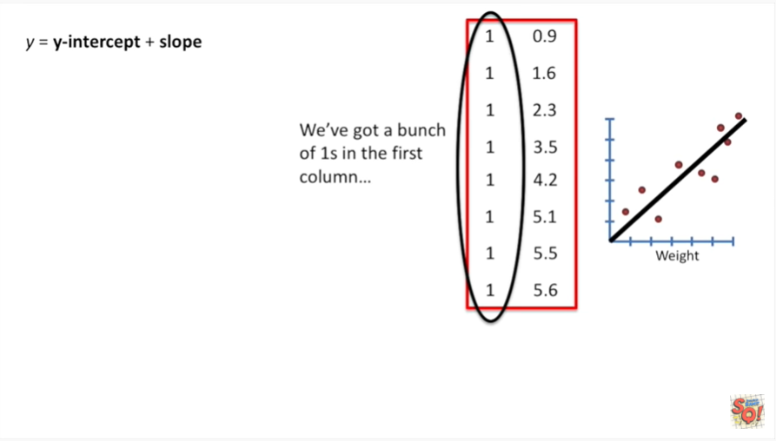

We've got a bunch of ones in the first column.

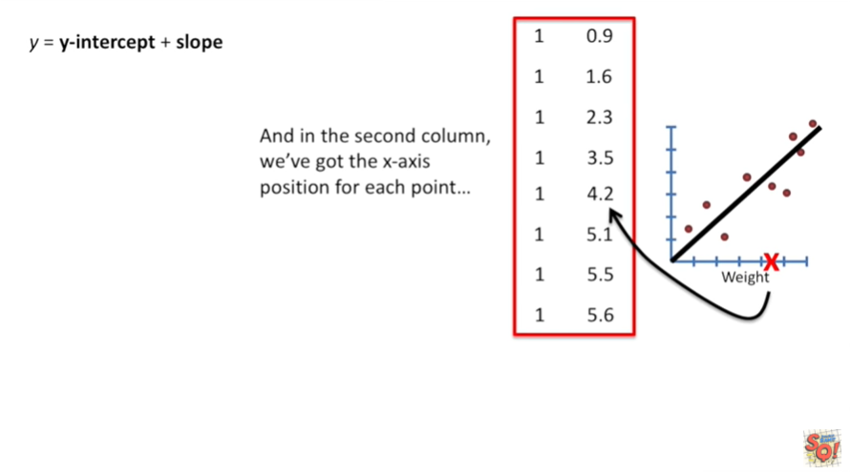

And in the second column we've got the x-axis position for each point.

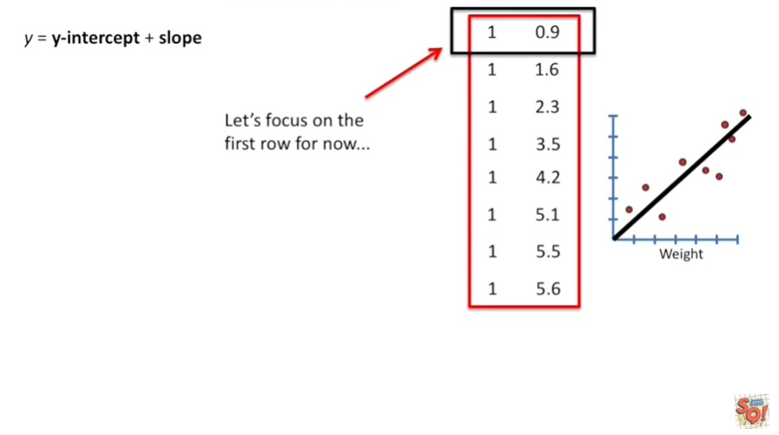

Let's focus on the first row in the design matrix.

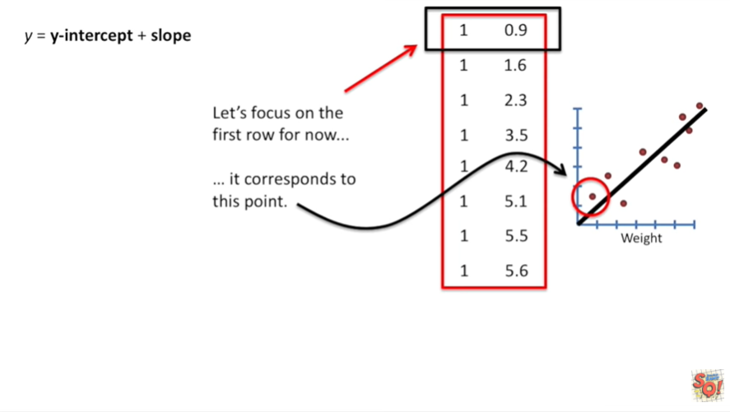

For now it corresponds to this point.

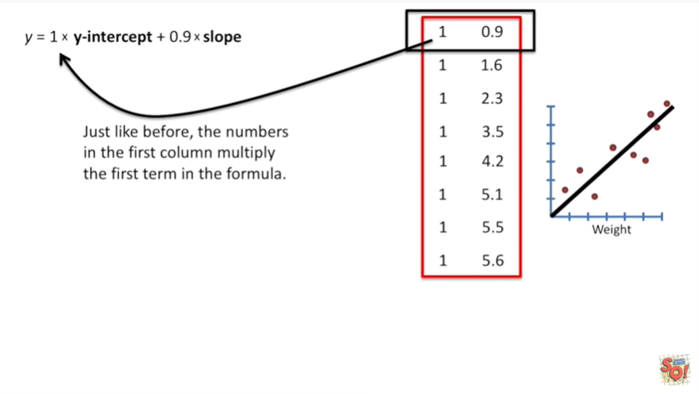

Just like before the numbers in the first column multiply the first term in the formula.

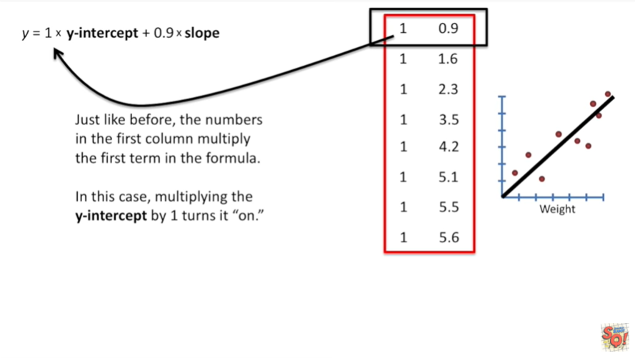

In this case multiplying the y-intercept by one turns it on.

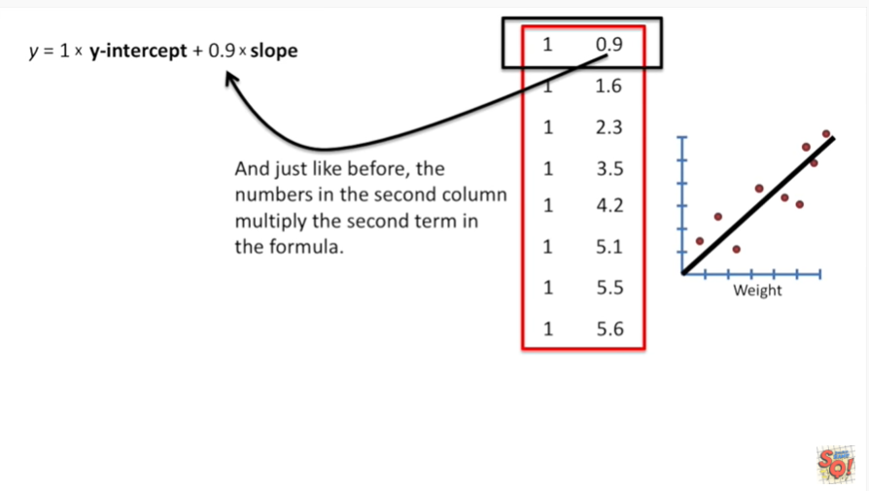

And just like before the numbers in the second column multiply the second term in the formula.

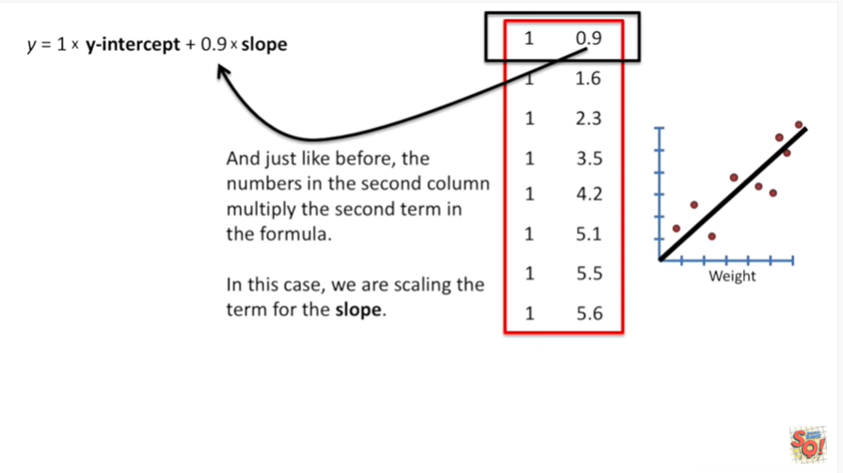

In this case we're scaling the term for the slope.

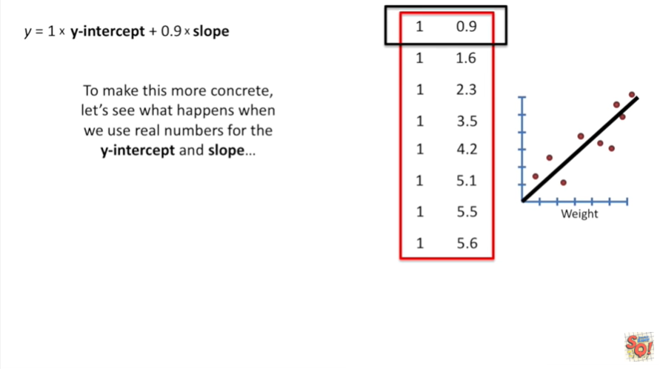

To make this more concrete let's see what happens when we use real numbers for the y-intercept and slope.

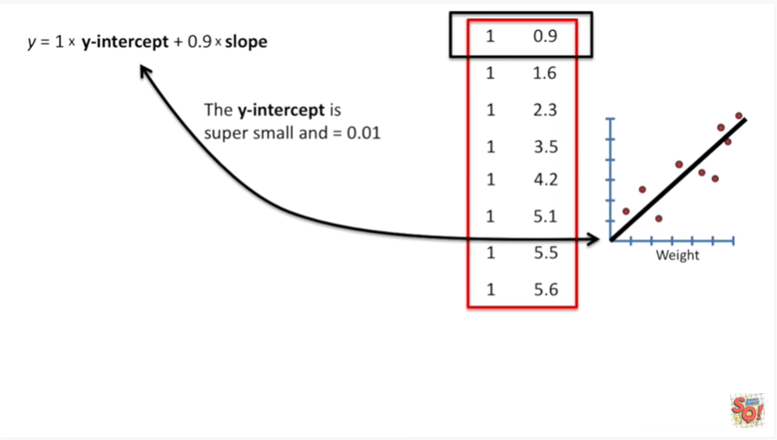

The y-intercept is super small N equals 0.01.

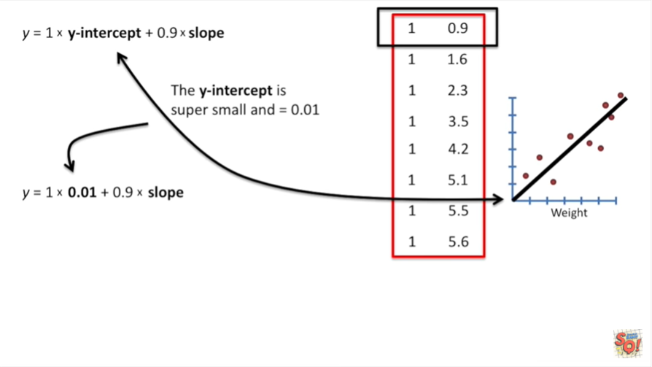

So that's the number we plug in here.

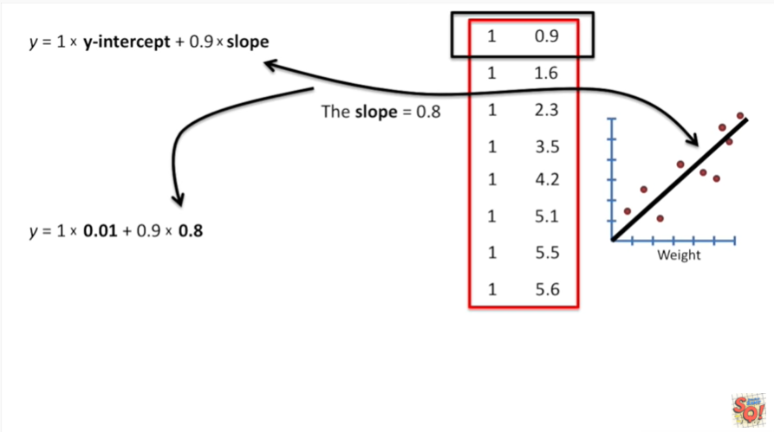

The slope equals zero point eight and we plug that in right here.

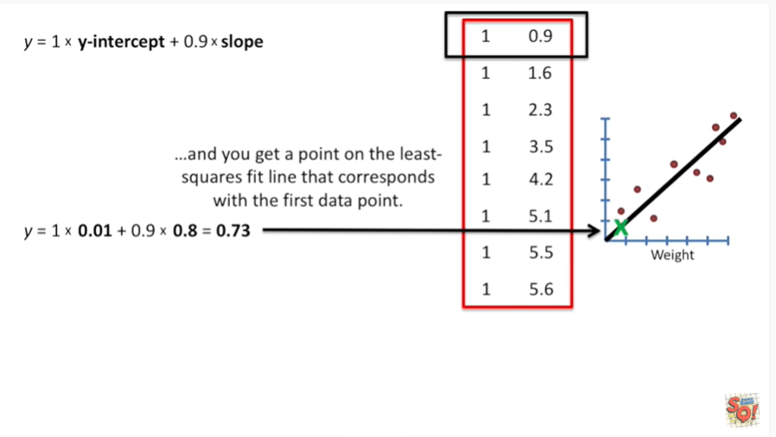

And now we do the math and you get a point on the least squares fit line that corresponds with the first data point.

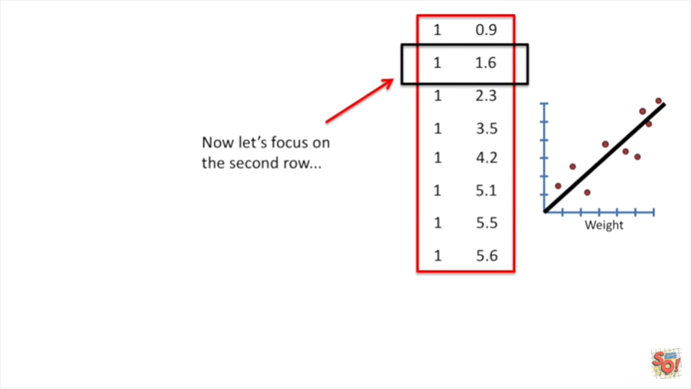

Now let's focus on the second row.

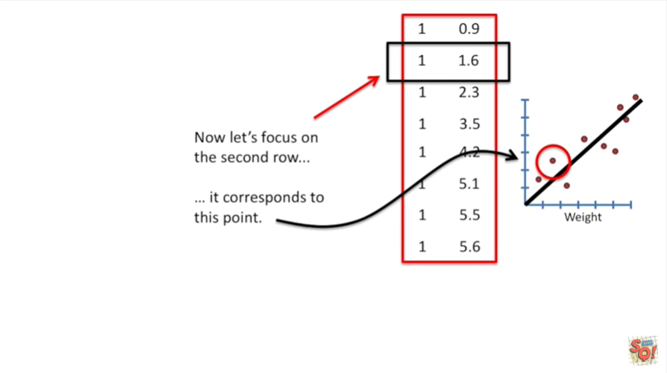

It corresponds to this point.

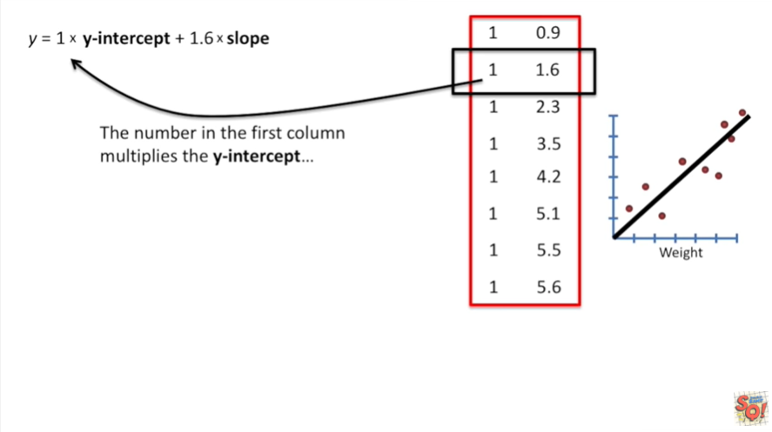

The number in the first column multiplies the y-intercept.

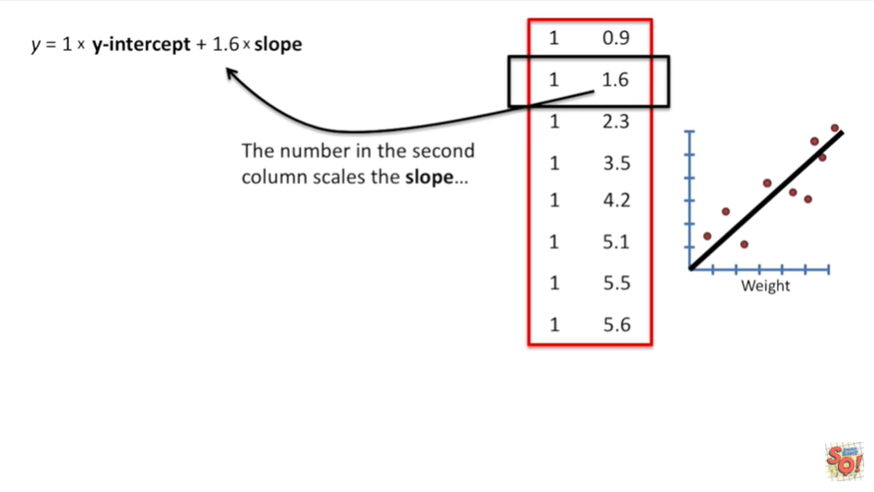

And the number in the second column scales the slope.

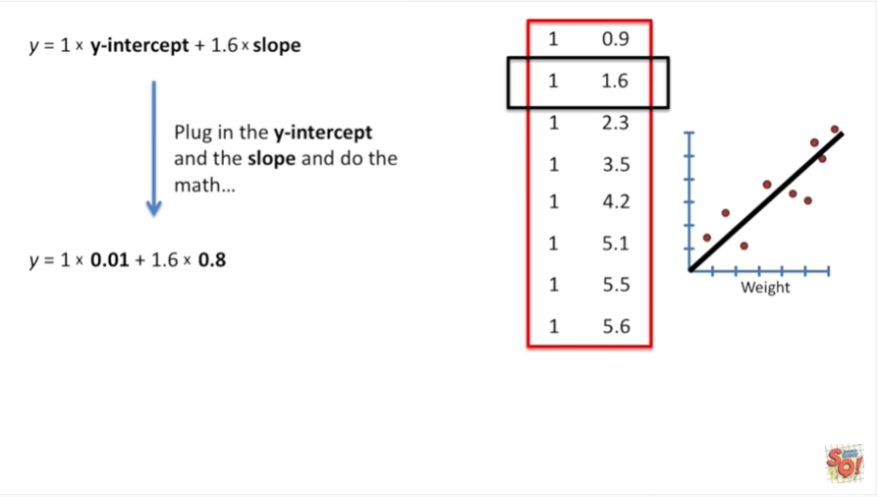

Plug in the y-intercept and the slope and do the math.

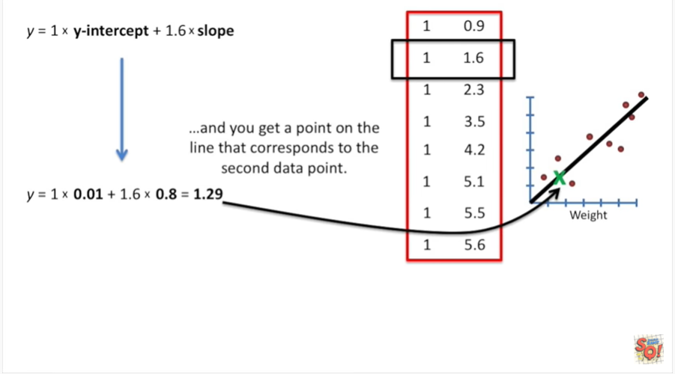

And you get a point on the line that corresponds to the second data point.

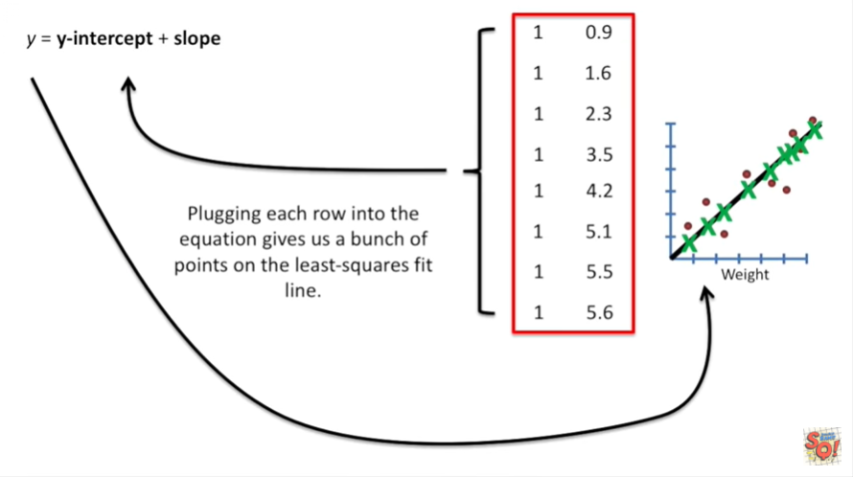

Plugging each row into the equation gives us a bunch of points on the least squares fit line.

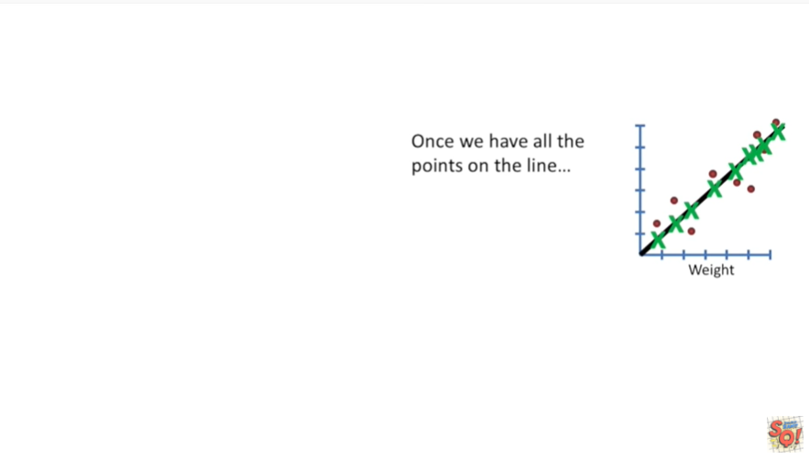

Once we have all the points on the line.

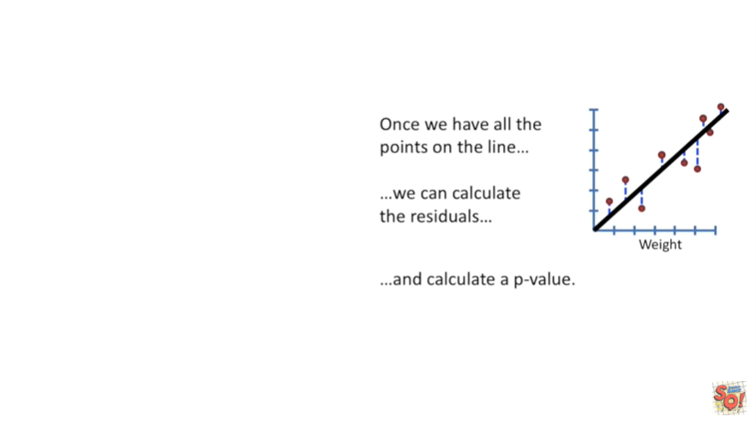

We can calculate the residuals.

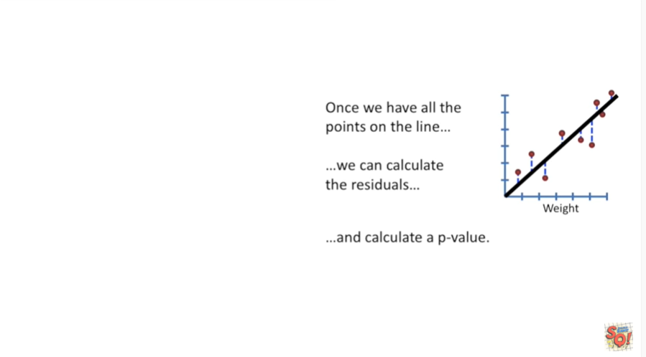

And that means we can calculate a p-value.

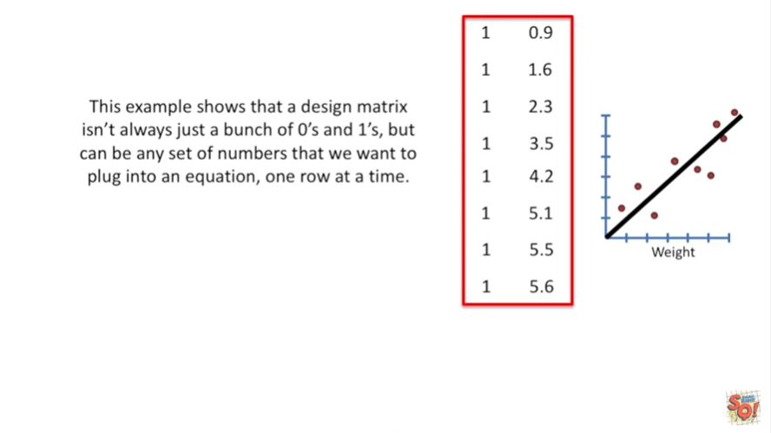

This example shows that a design matrix isn't always just a bunch of zeros and ones but can be any set up numbers that we want to plug into an equation one row at a time.



One note before we move on.

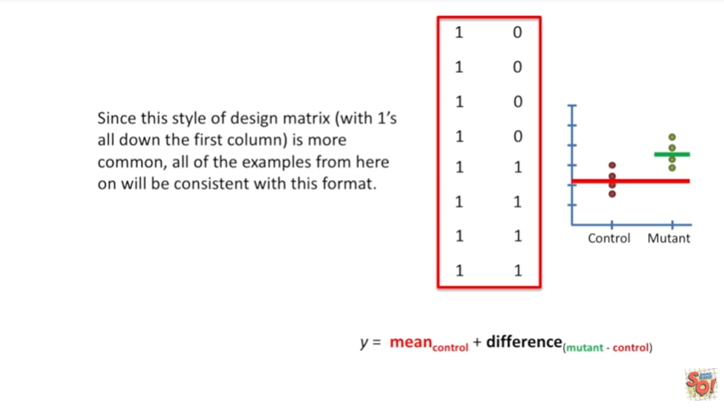

Since this style of design matrix with one's all the way down the first column is more common, all of the examples from here on out will be consistent with this format.



Now that we know we can put any number into the design matrix let's do something fancy.



Let's combine a t-test and a regression.

Holy smokes that's totally crazy.

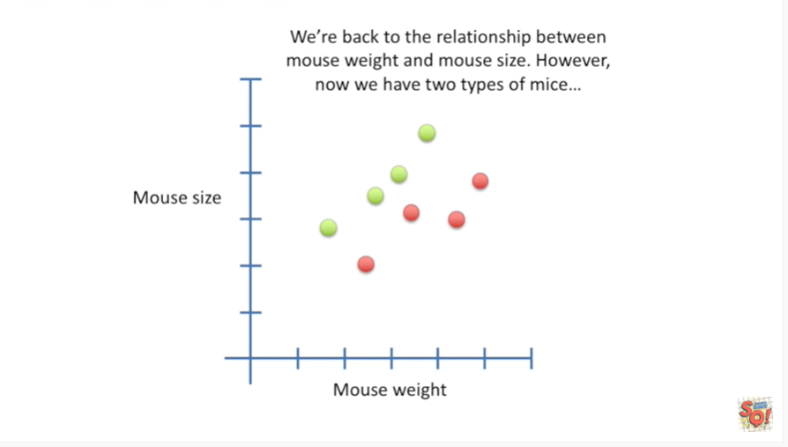

Okay we're back to the relationship between mouse weight and mouse size.

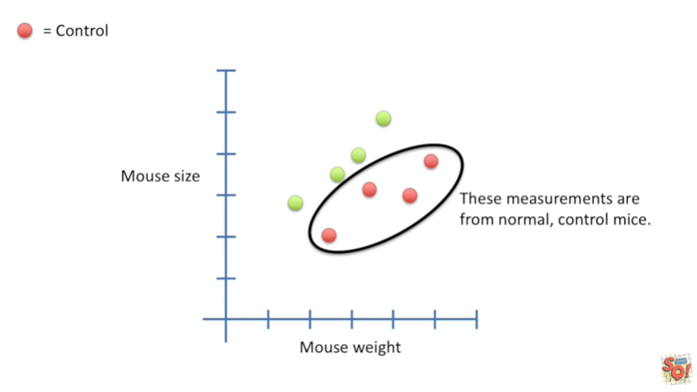

However we have two types of mice.

These measurements are from normal control mice.

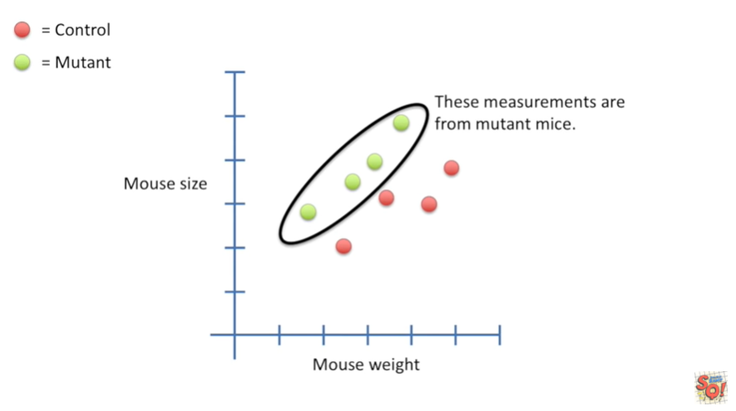

These measurements are from mutant mice that make them tall and skinny.

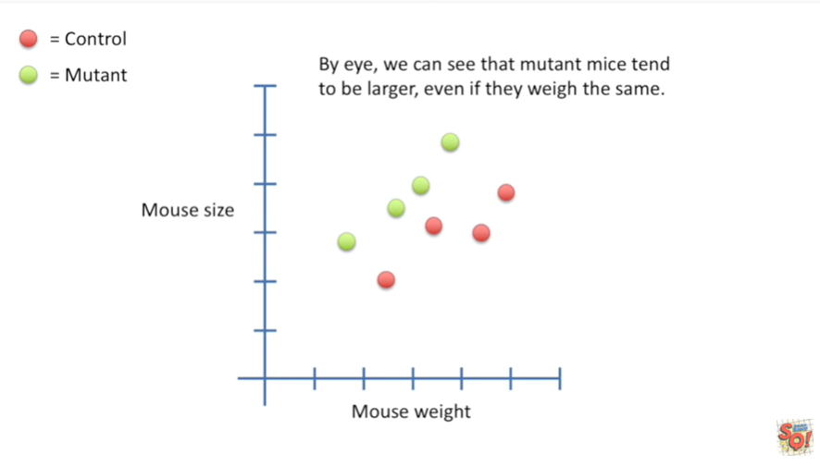

By eye, we can see that mutant mice tend to be larger even if they weigh the same.

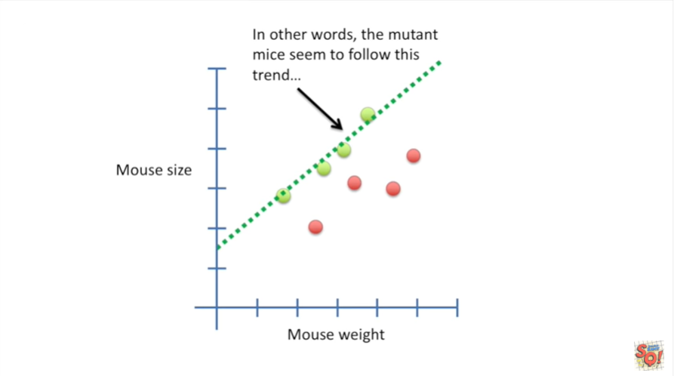

In other words the mutant mice seem to follow this trend.

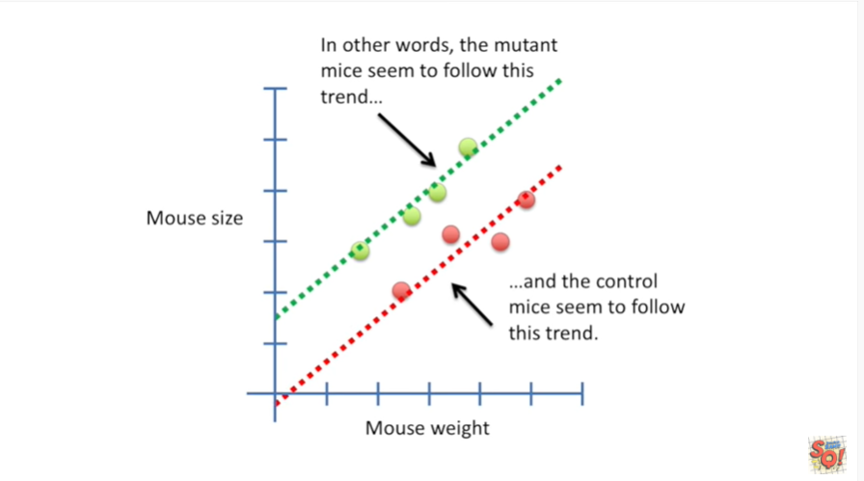

In the control mice seem to follow this trend.

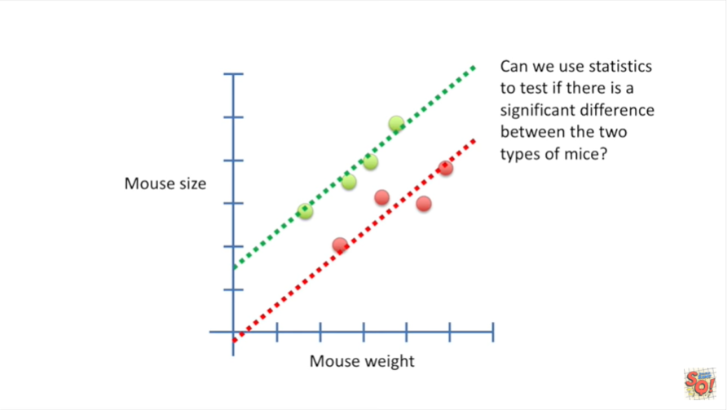

Can we use statistics to test if there is a significant difference between the two types of mice ?

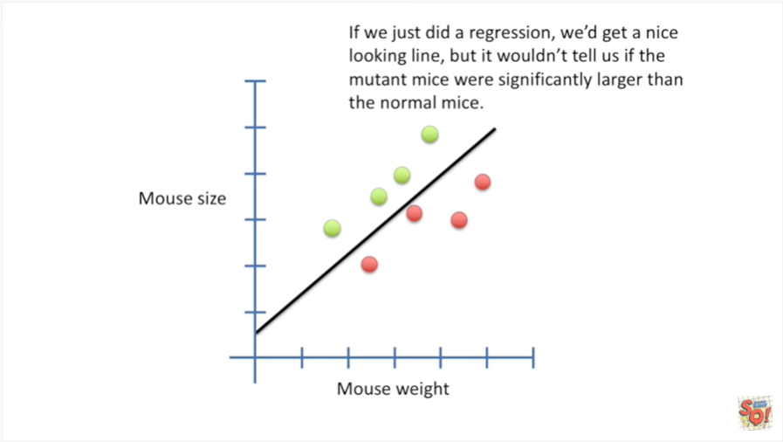

If we just did a regression we'd get a nice looking line but it wouldn't tell us if the mutant mice were significantly larger than the normal mice.

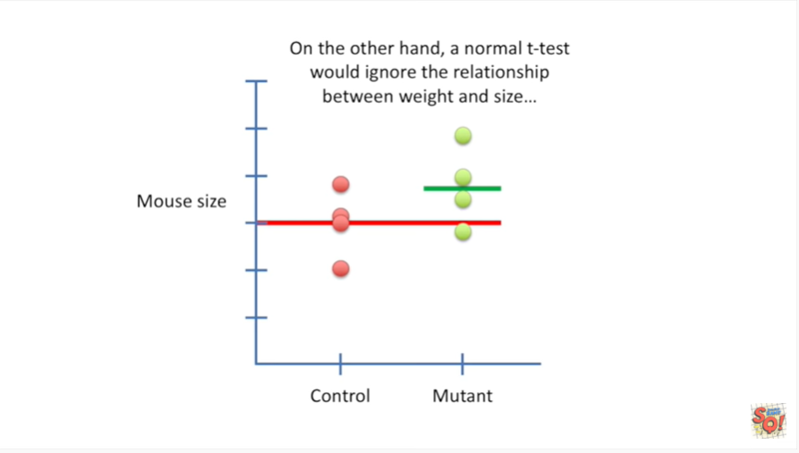

On the other hand a normal t-test would ignore the relationship between weight and size.

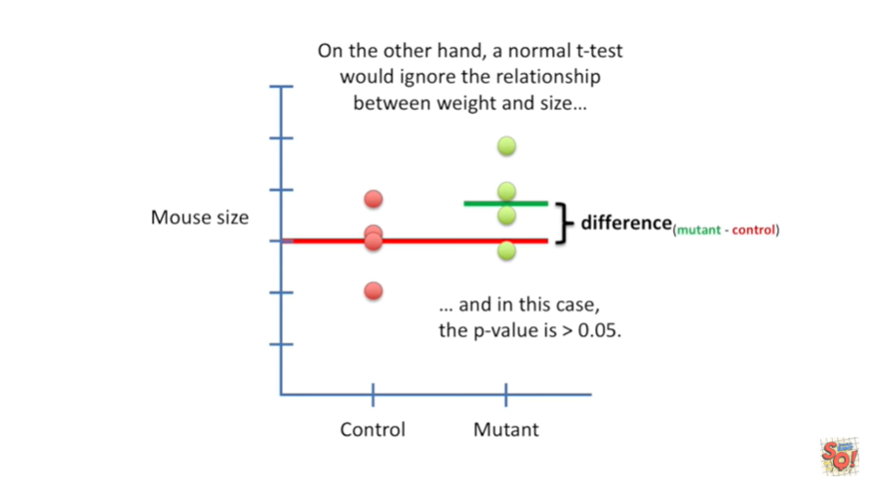

And in this case the p-value is greater than 0.05.

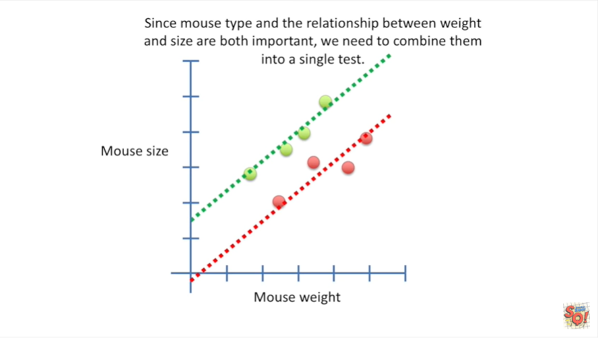

Since Mouse type and the relationship between weight and size are both important we need to combine them into a single test.

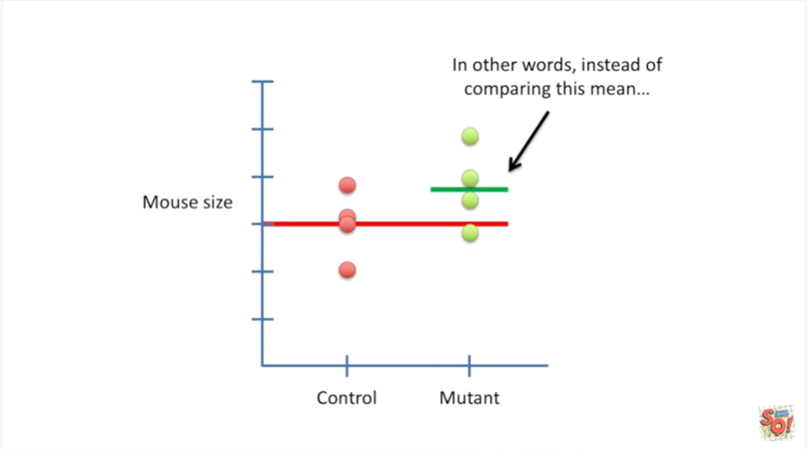

In other words instead of comparing this mean

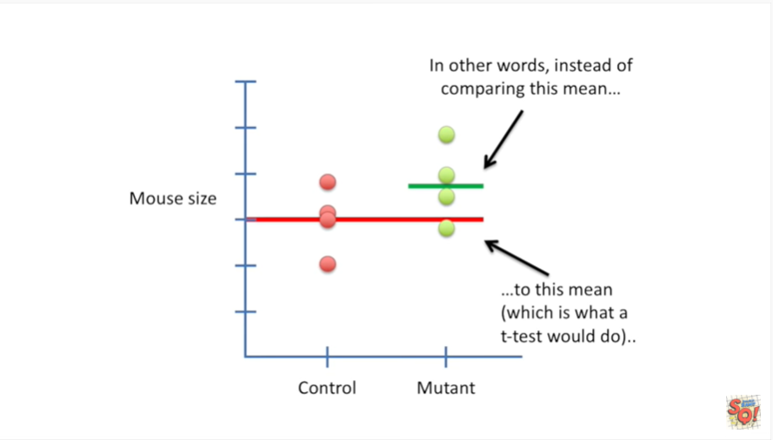

to this mean which is what a t-test would do.

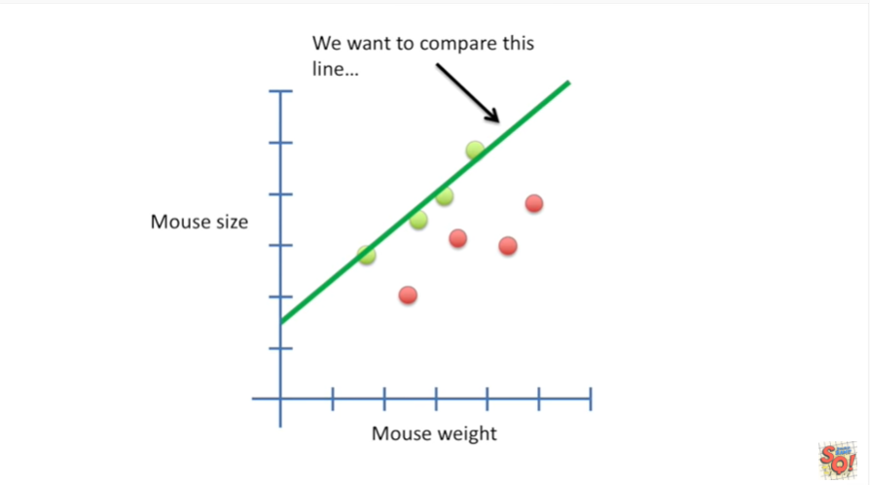

We want to compare this line

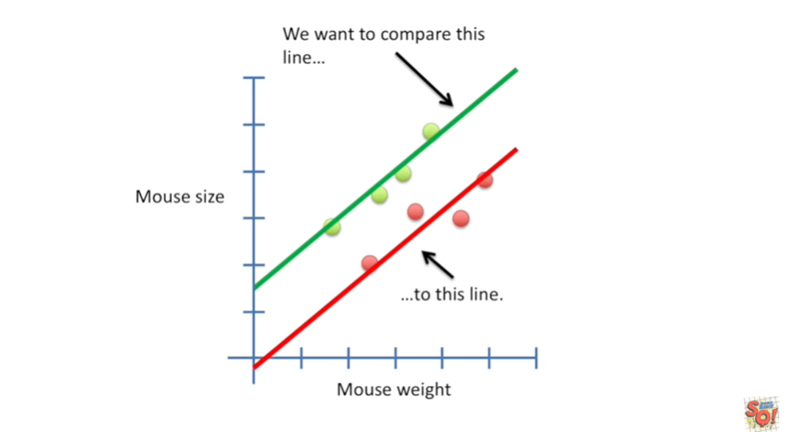

to this line

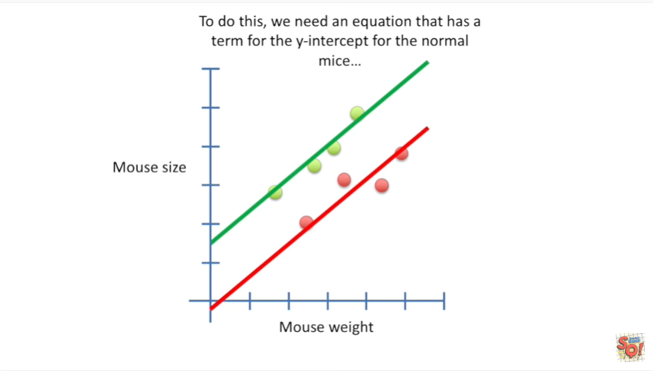

To do this we need an equation that has a term

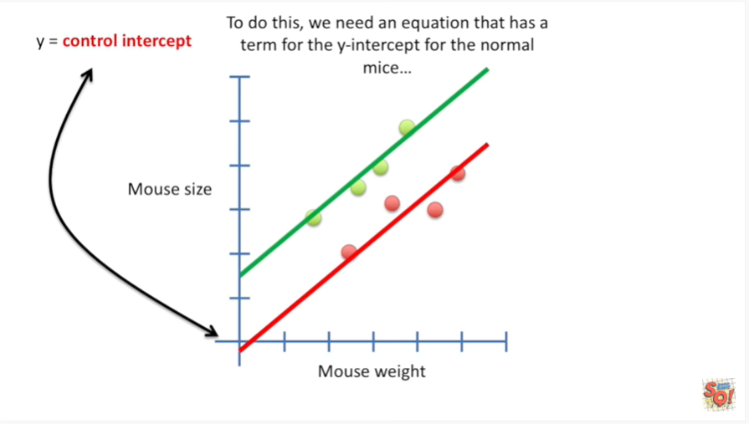

for the y-intercept for the normal mice.

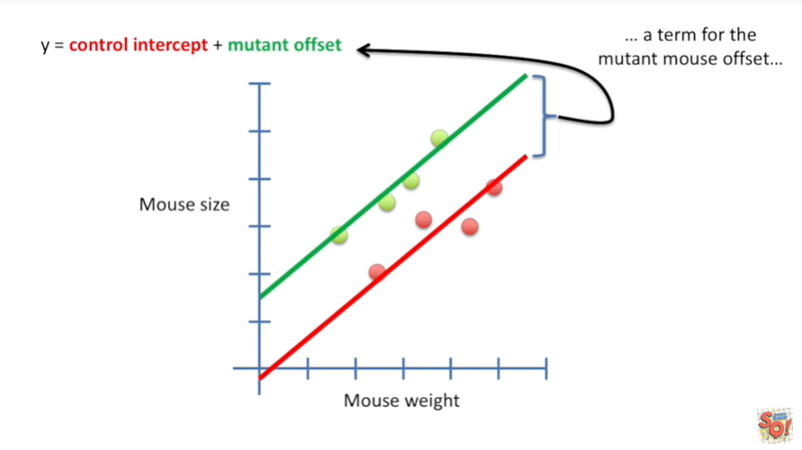

We also need a term for the mutant mouse offset.

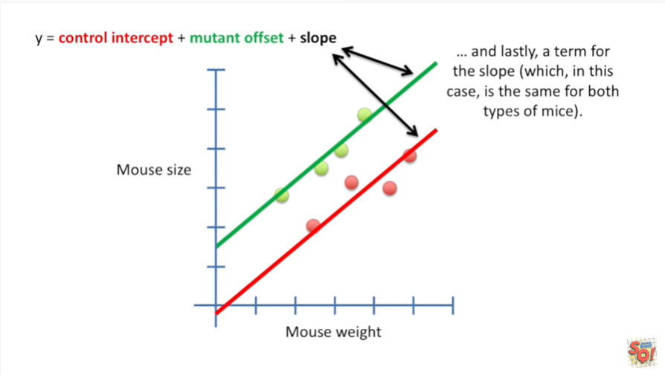

And lastly a term for the slope which in this case is the same for both types of mice.

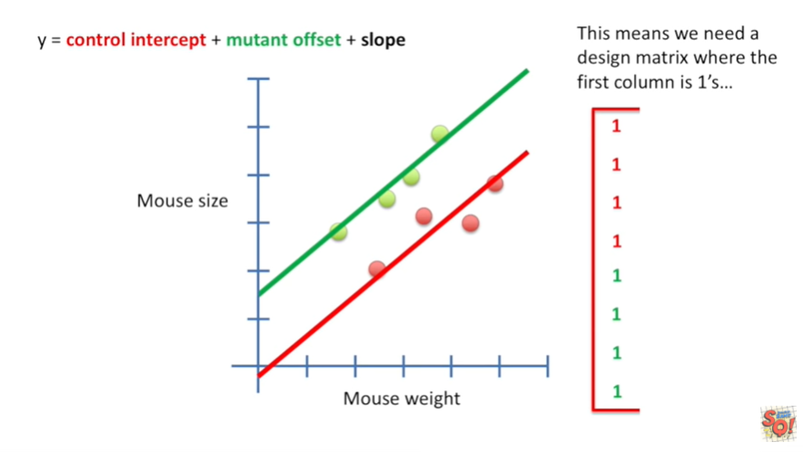

This means we need to design matrix where the first column is ones.

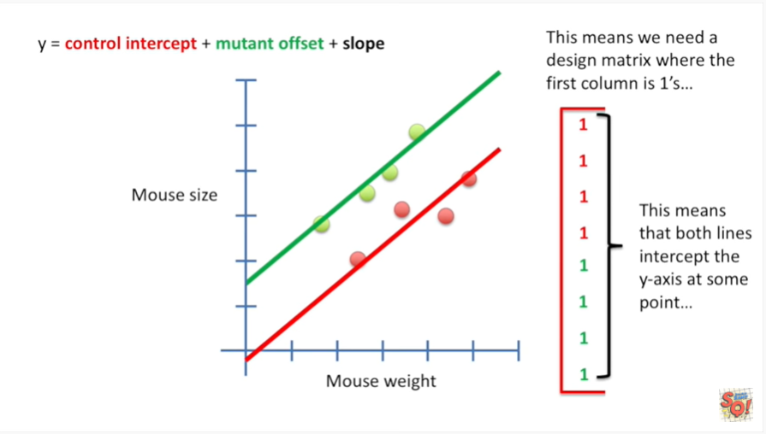

This means that both lines intercept the y-axis at some point.

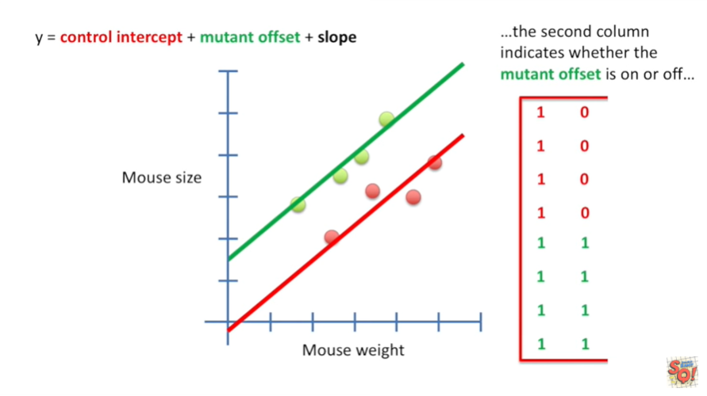

he second column indicates whether the mutant offset is on or off.

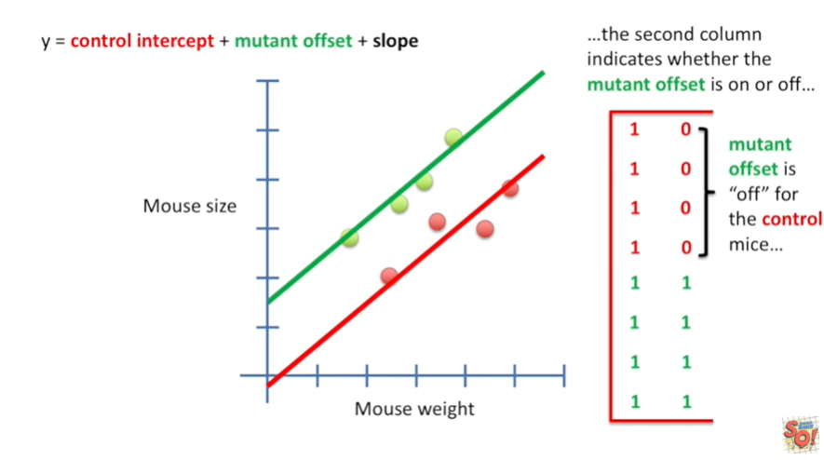

The mutant offset is off for the control mice

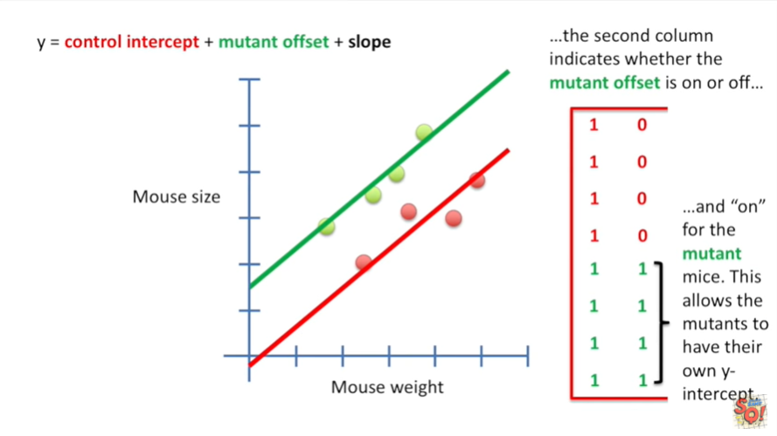

and on for the mutant mice.

This allows the mutants to have their own y-intercept.

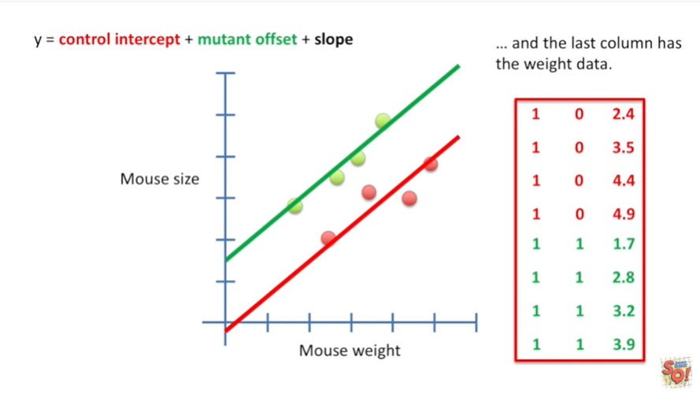

And the last column has the weight data.

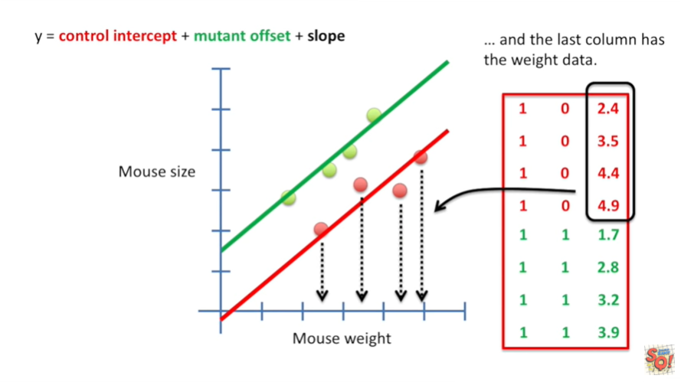

The first four values are the x coordinates for the control mice.

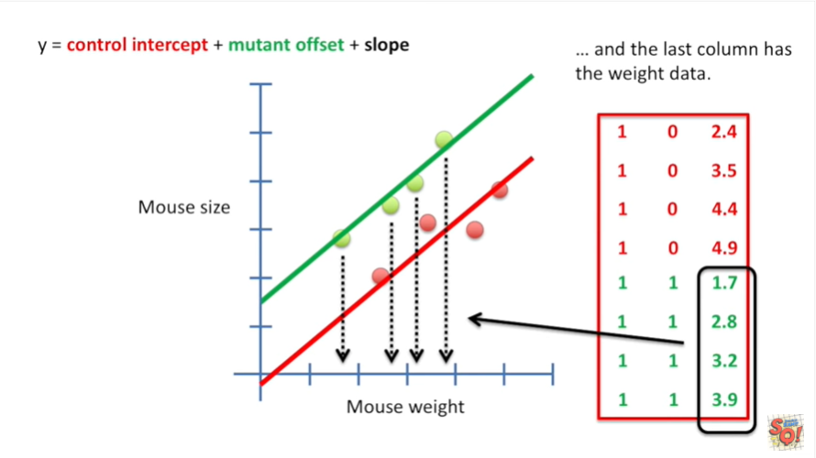

And the last four values are the x coordinates for the mutant mice.

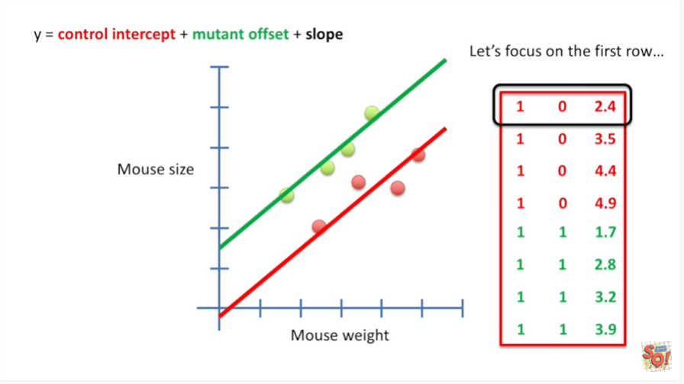

Let's focus on the first row.

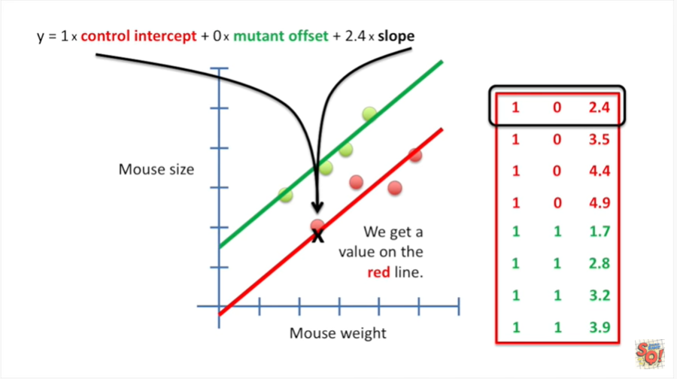

Plug in the numbers and we get a value on the red line.

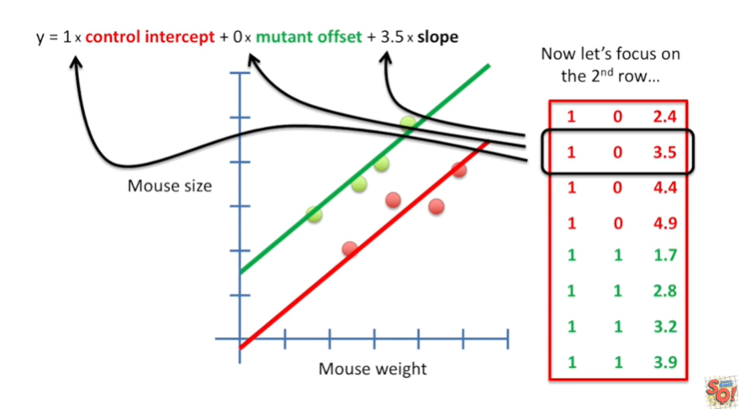

Now let's focus on the second row.

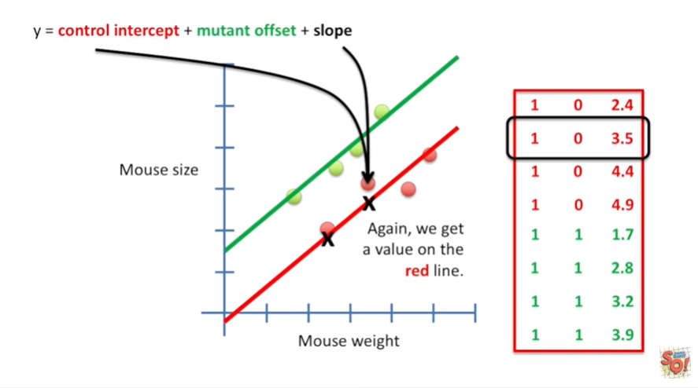

Again we get a value on the red line.

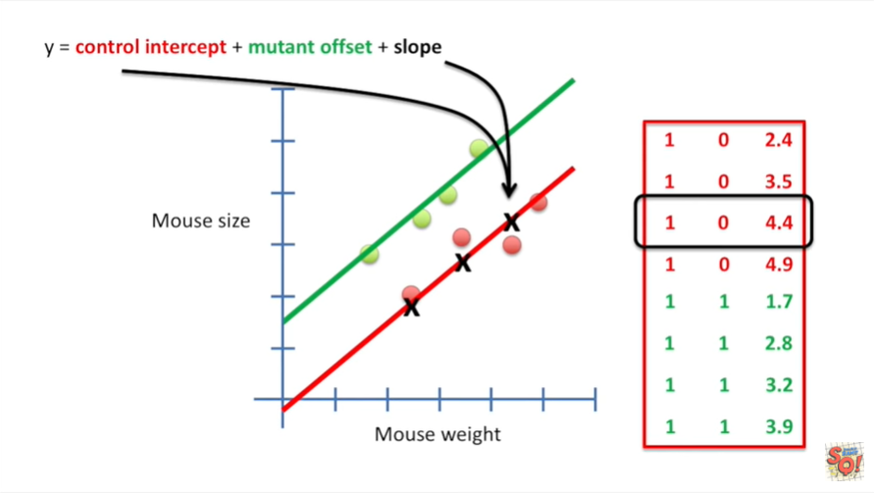

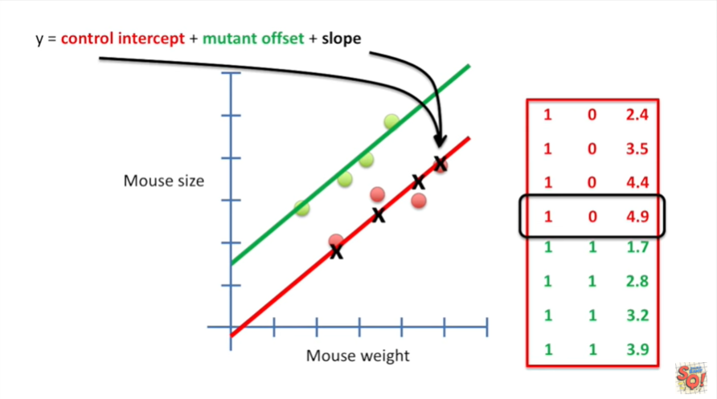

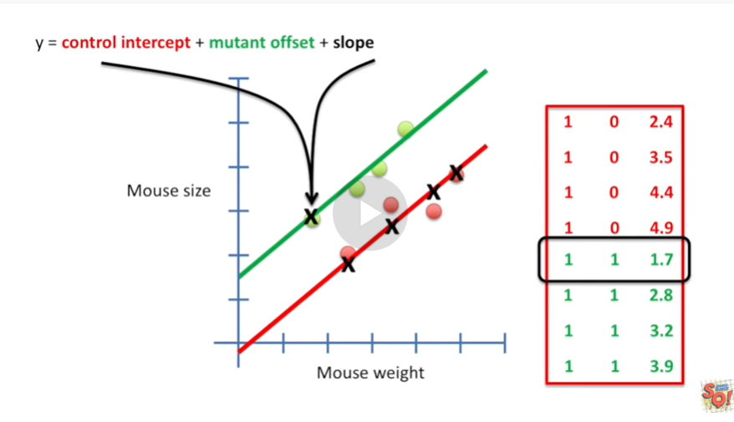

And from here we just plug in the values and we get coordinates on either the red or the green line.

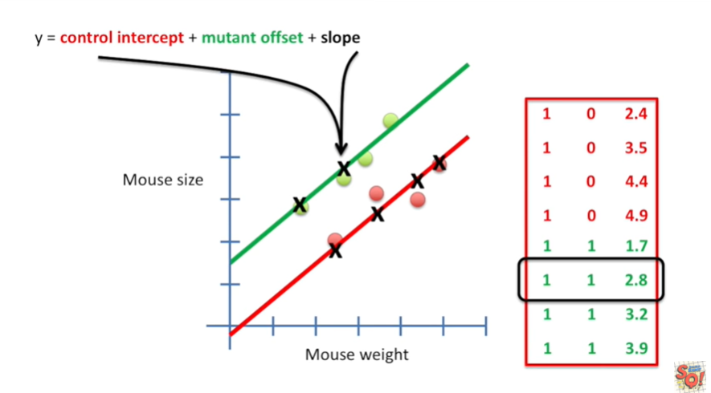

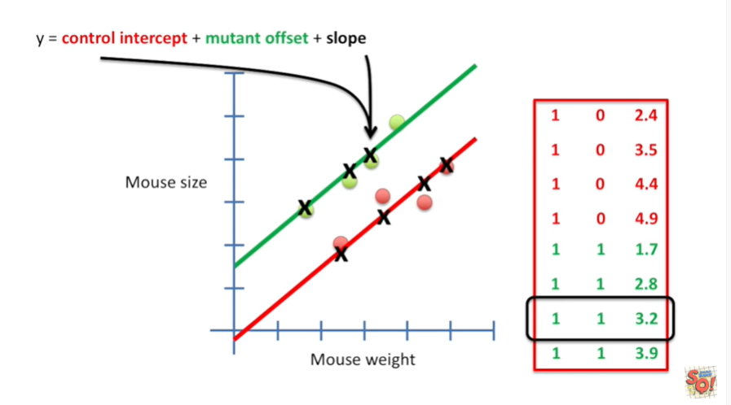

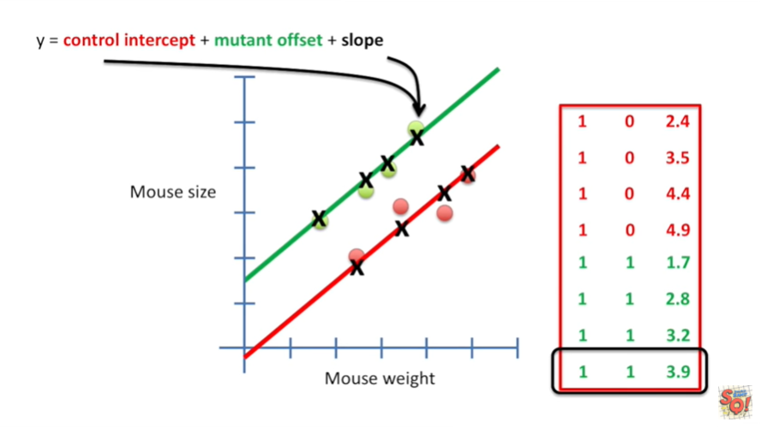

We get coordinates on the red line when the mutant offset is off.

And we get coordinates on the green line when the mutant offset is on.

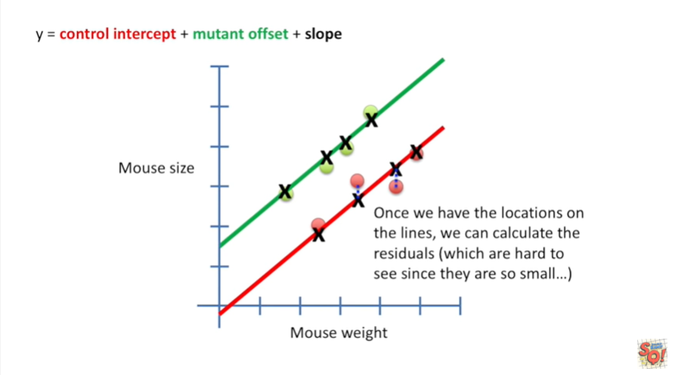

Once we have the locations on the lines we can calculate the residuals which are hard to see since they are so small in this example.

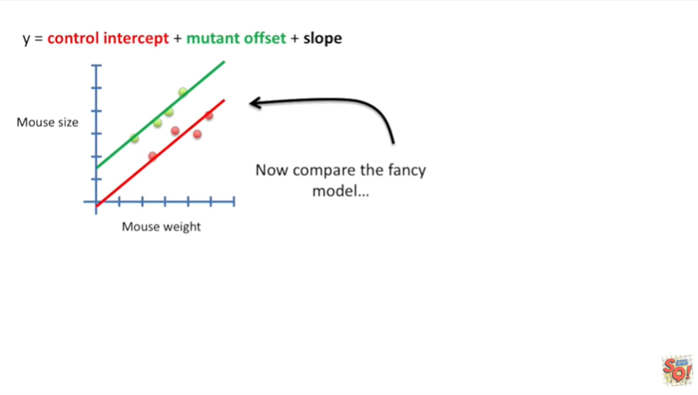

Now we can compare the fancy model

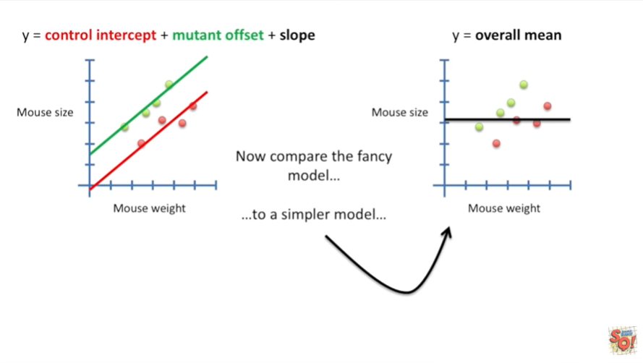

to a simpler model.

In the simpler model we model Mouse size by using just the average size of the mouse.

We ignore Mouse weight and we ignore Mouse type.

This is the default model that we use when we do the t-test.

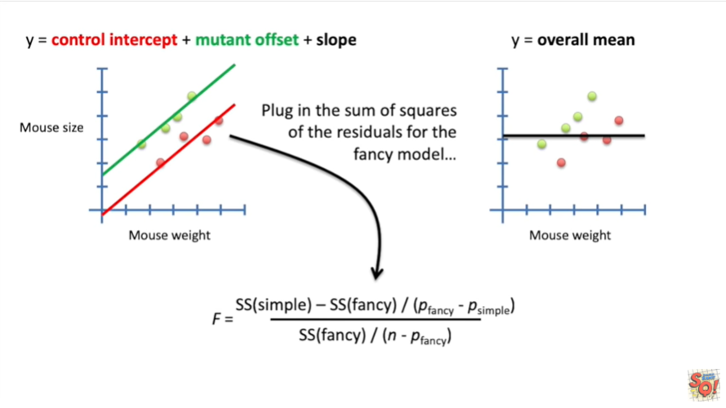

Now we plug in the sum of squares of the residuals for the fancy model.

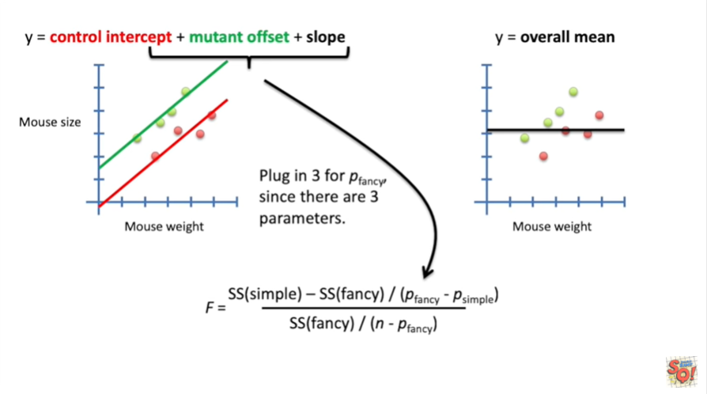

And we plug in 3 for the P fancy term since there are 3 parameters in our fancy equation.

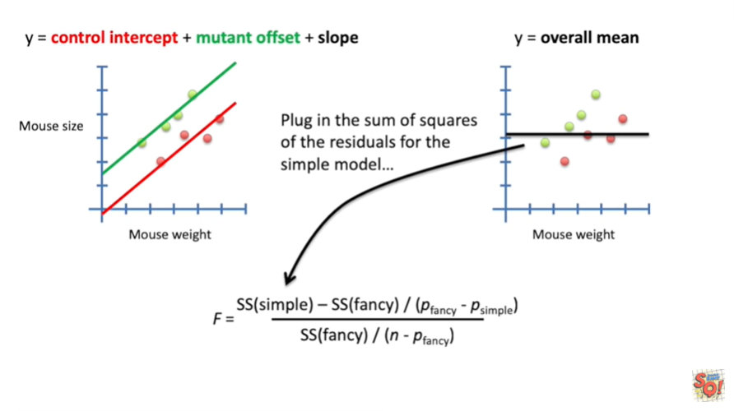

And we plug in the sum of squares of the residuals for the simple model.

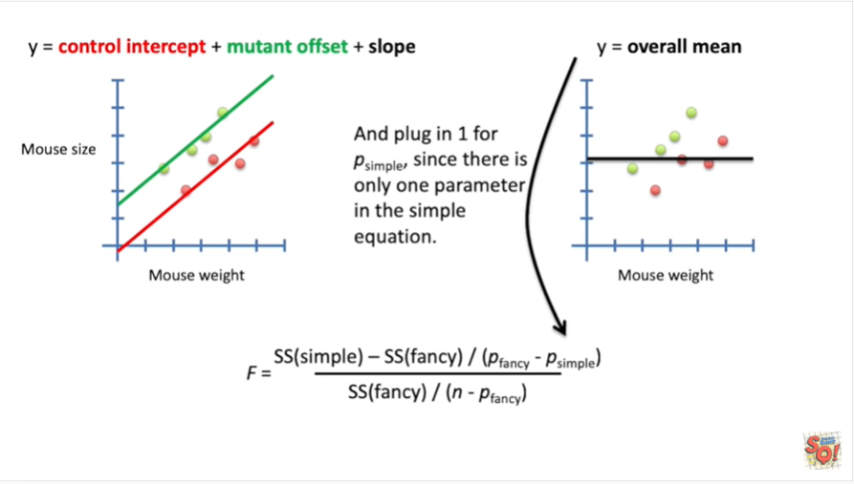

And we plug in one for the P simple term since there is only one parameter in the simple equation.

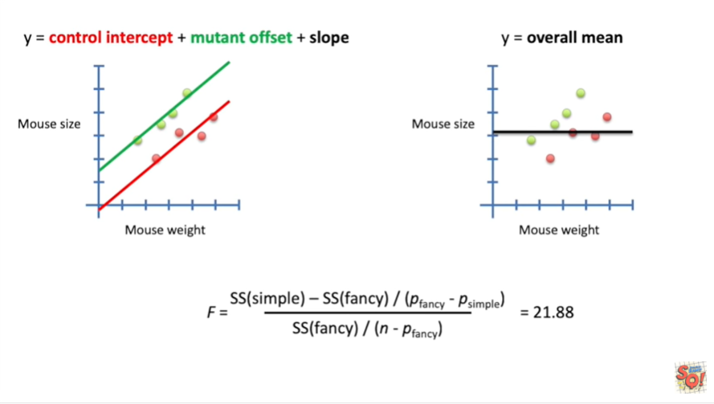

This gives us 20 1.88.

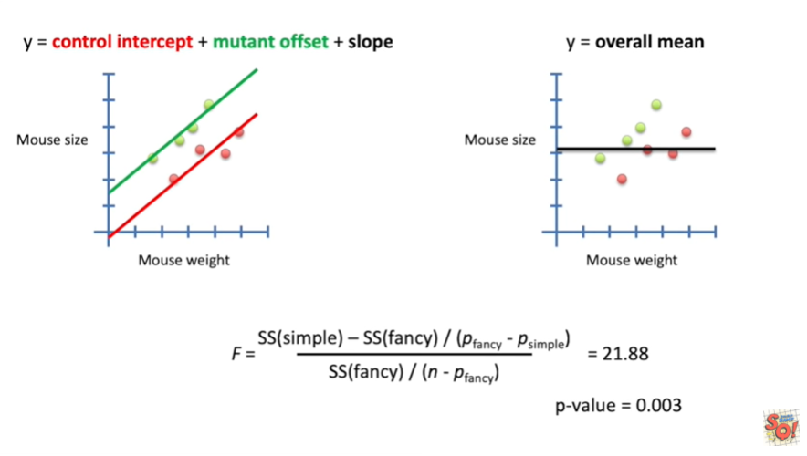

And that gives us a p-value of 0.003.

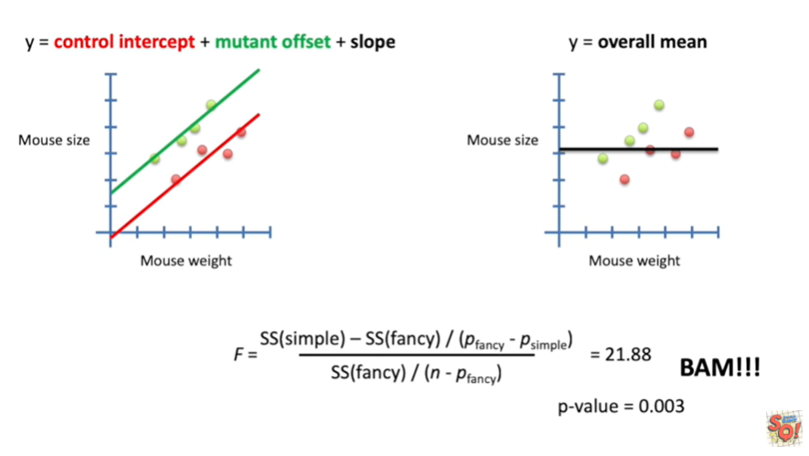

BAM.

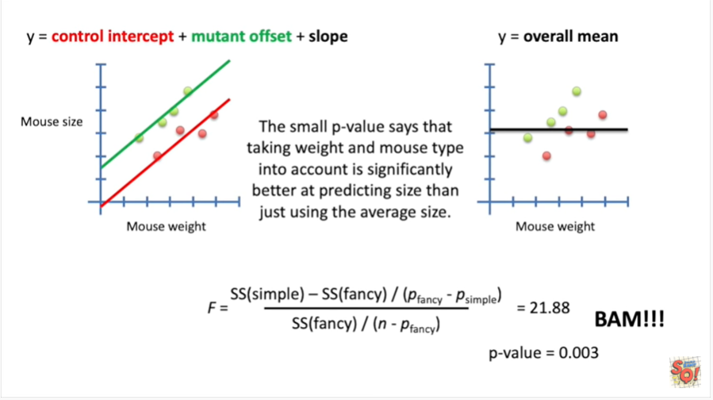

The small p-value says that taking weight and Mouse type into account is significantly better at predicting size than just using the average size.

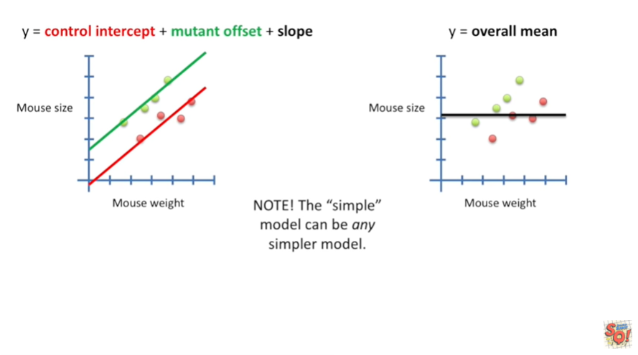

Note the simple model can be any simpler model.

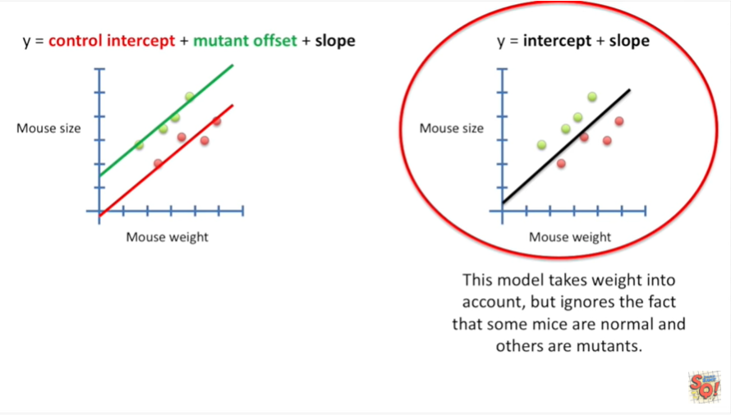

If we did a super simple linear regression we'd have a model that takes weight into account but ignores the fact that some mice are normal and others are mutants.

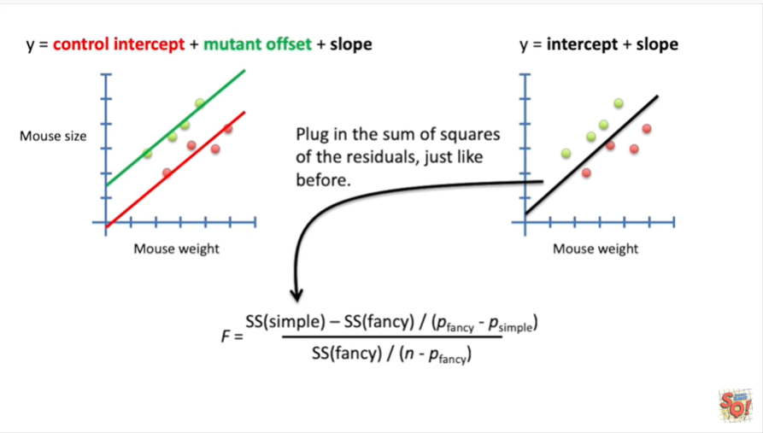

Then we plug in the sum of squares of the residuals just like before.

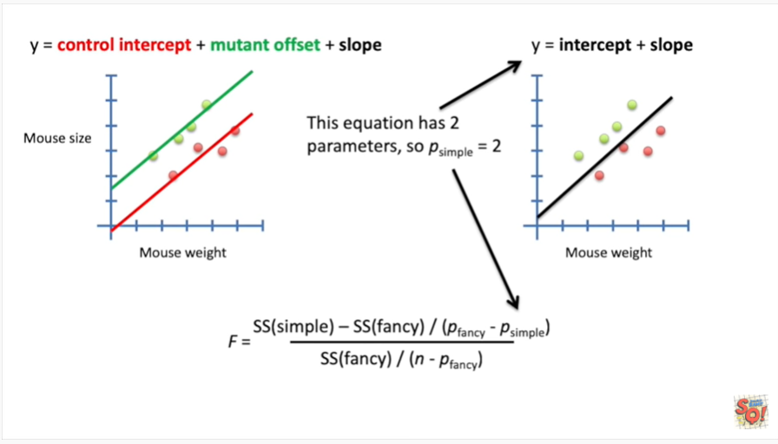

The simple regression equation has two parameters so P simple equals 2.

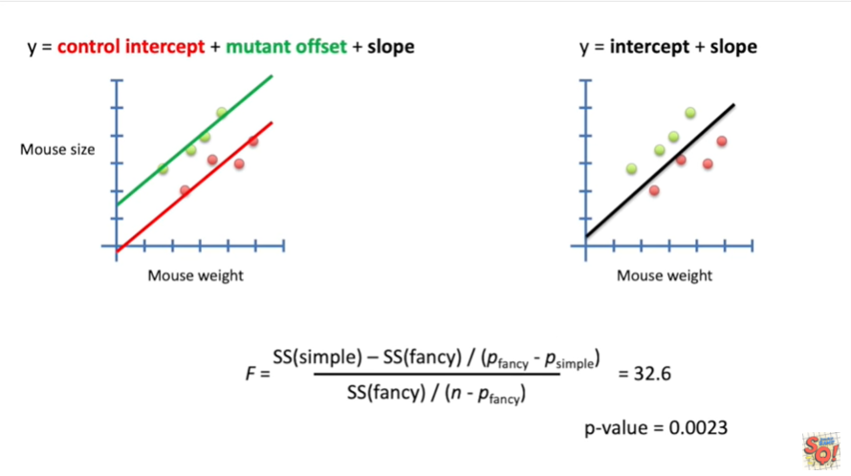

We then plug in the numbers and we get a p-value equal to zero point zero zero two three.

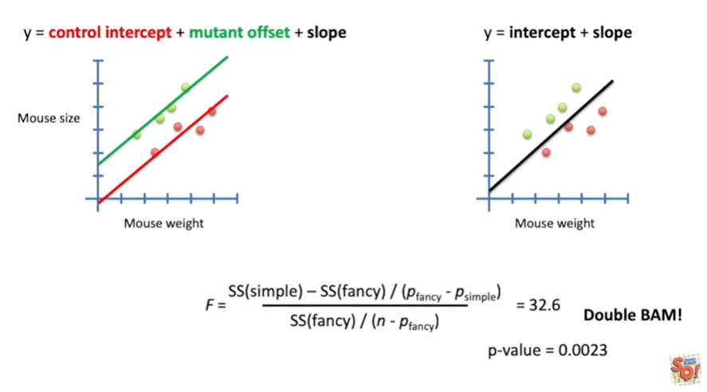

Double BAM.

This small p-value suggests that using both weight and mouse type is better at predicting Mouse size than weight alone.

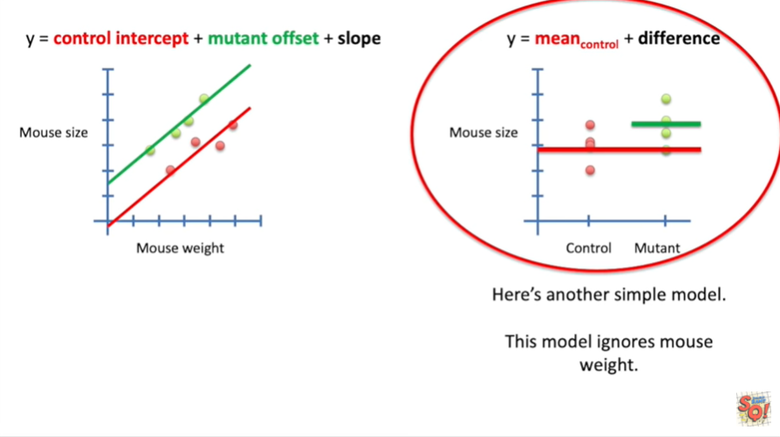

Here's another simple model it's just a normal t-test.

This model ignores Mouse weight.

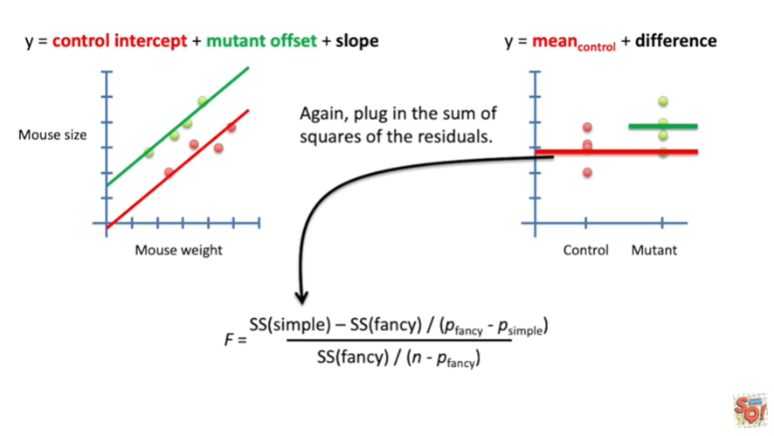

Again plug in the sum of squares of the residuals.

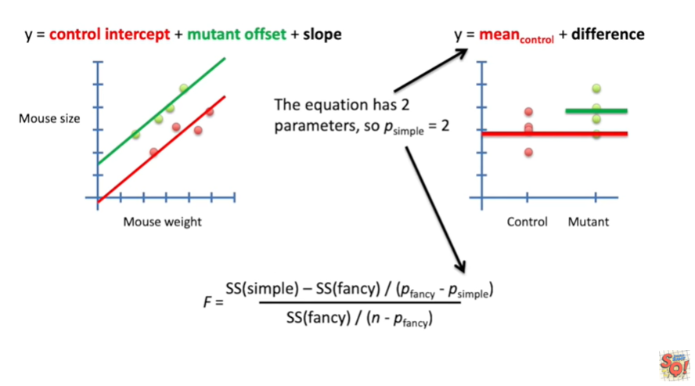

In the equation has two parameters.

So P simple equals two.

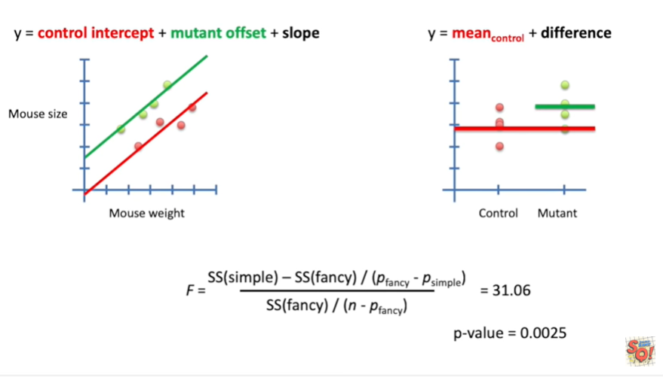

And that gives us a p-value equal to zero point zero zero two five.

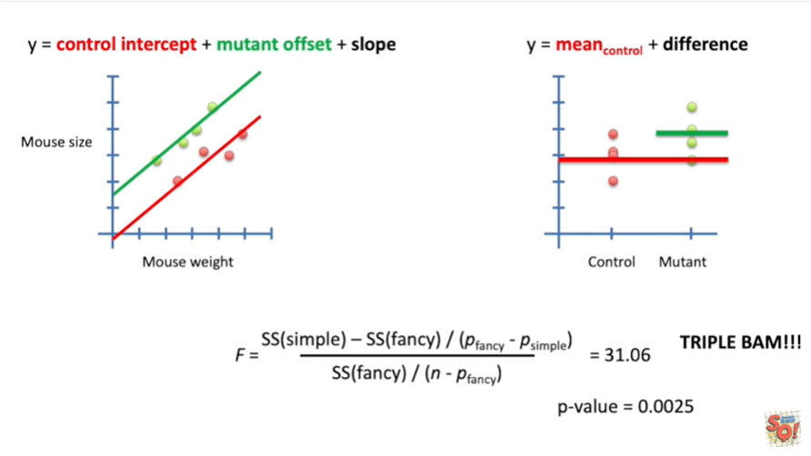

Oh my gosh it's the coveted triple bam.

This small p-value suggests that using mouse weight and type is better at predicting Mouse size than Mouse type alone.

So you can see that the question you want to ask determines what type of simple model you want to use to compare your fancy model to.



Okay one last example of a design matrix.

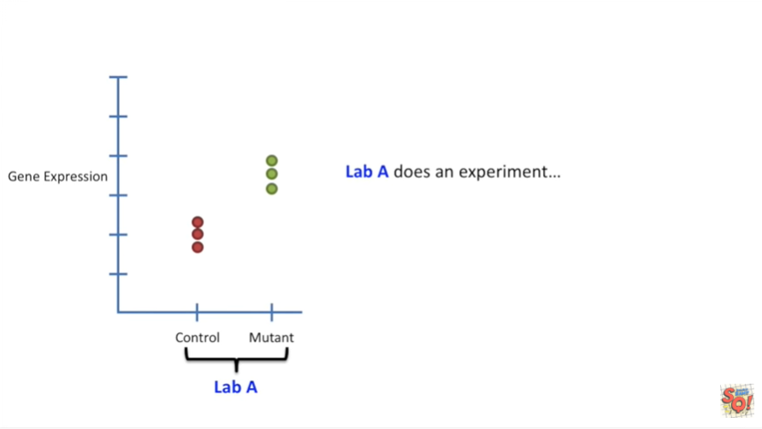

Lab a dozen experiment.

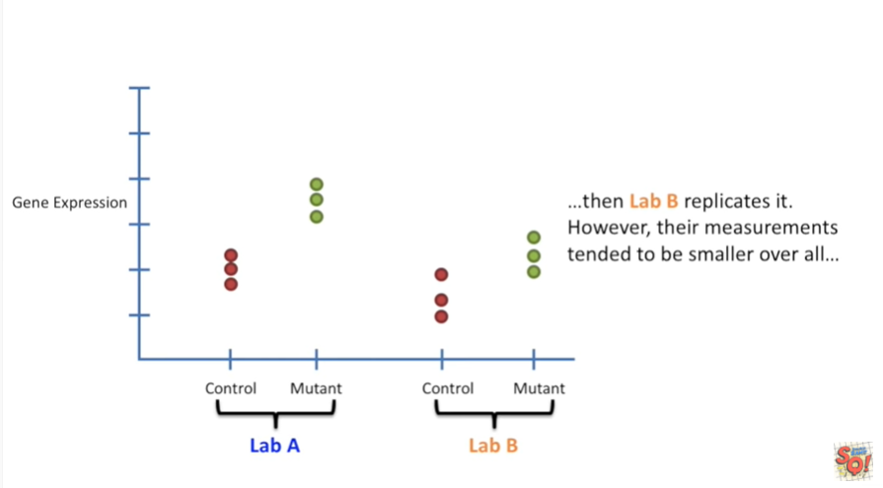

Then lab B replicates it.

However their measurements tended to be smaller overall.

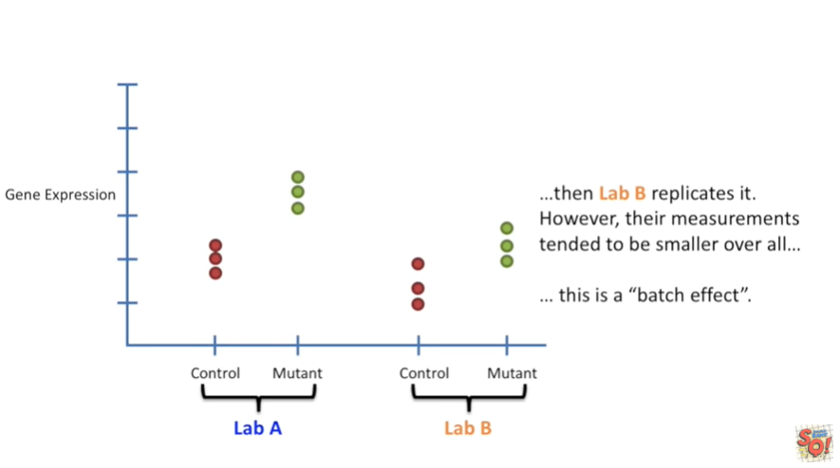

This is a batch effect.

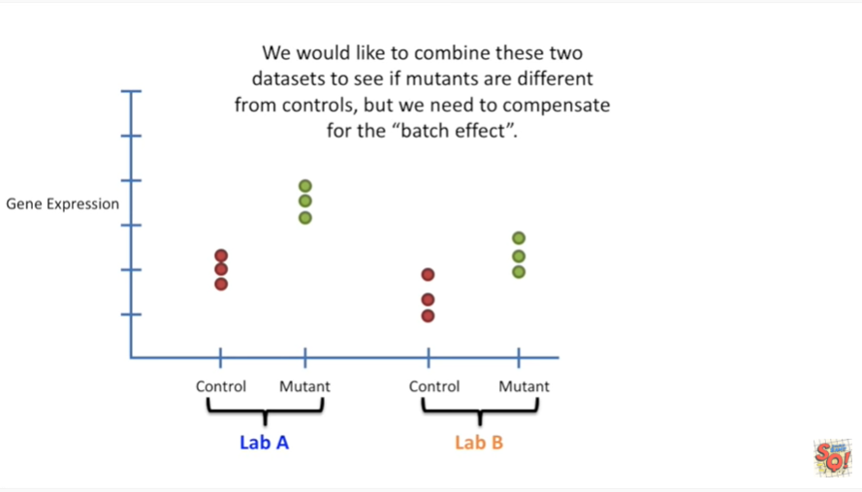

We would like to combine these two datasets to see if mutants are different from controls but we need to compensate for the batch effect.

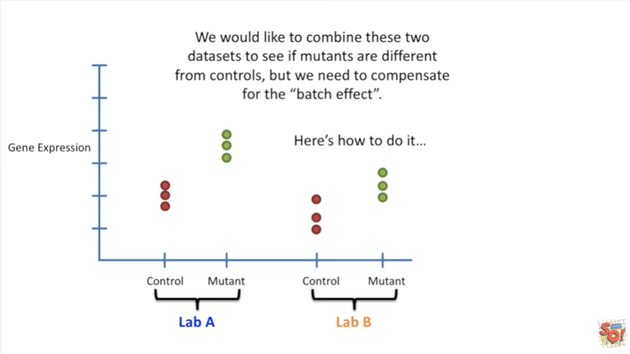

Here's how to do it.

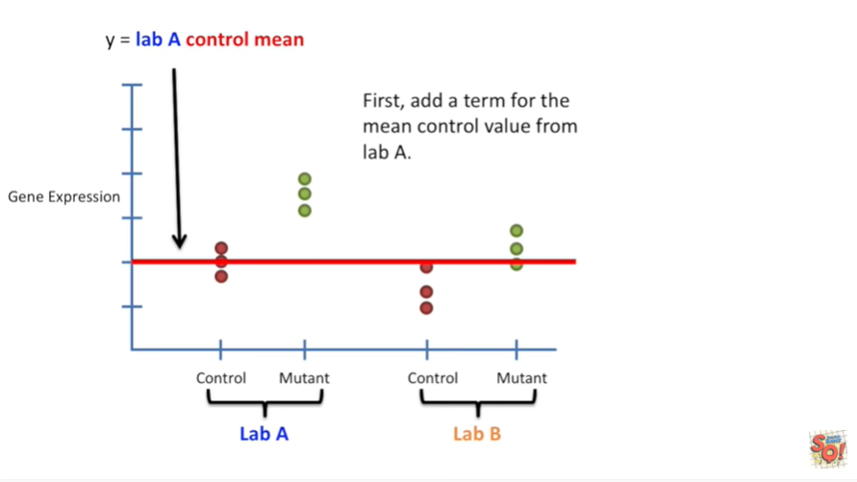

First add a term for the mean control value from lab a.

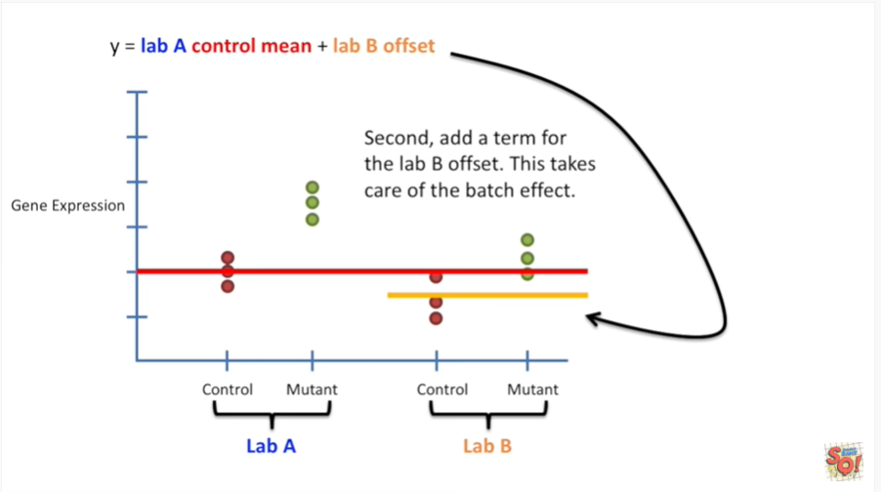

Second add a term for the lab B offset.

This takes care of the batch effect.

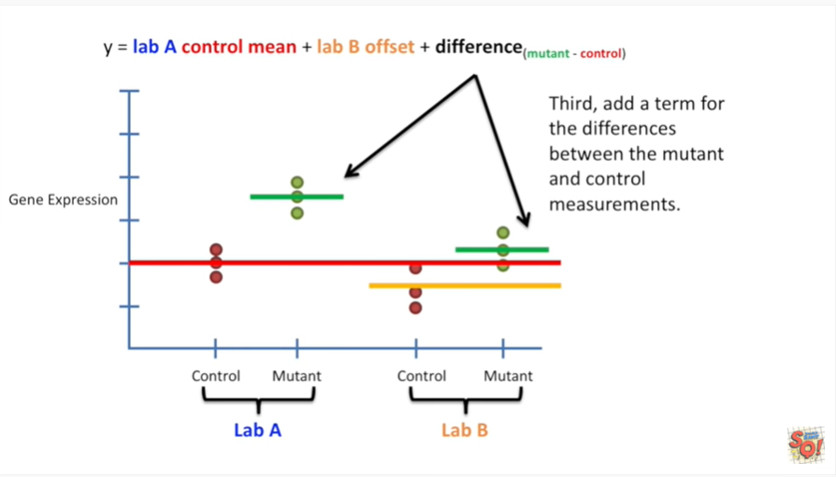

Third add a term for the differences between the mutant and the control measurements.

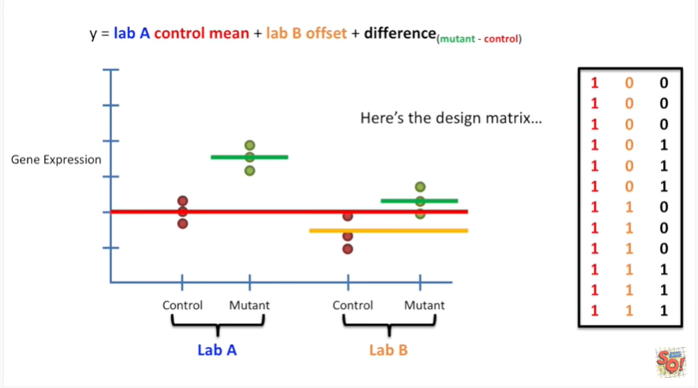

Here's the design matrix.

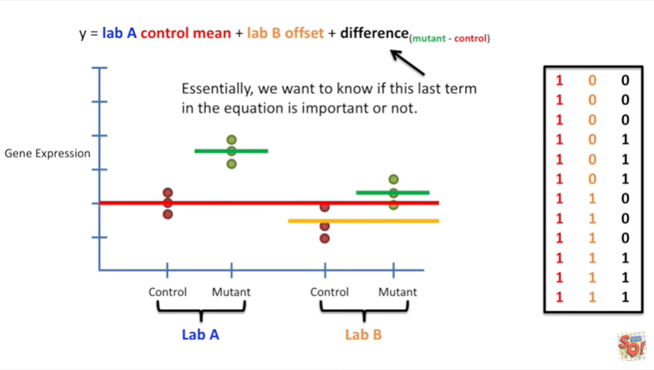

Essentially we want to know if this last term in the equation is important or not.

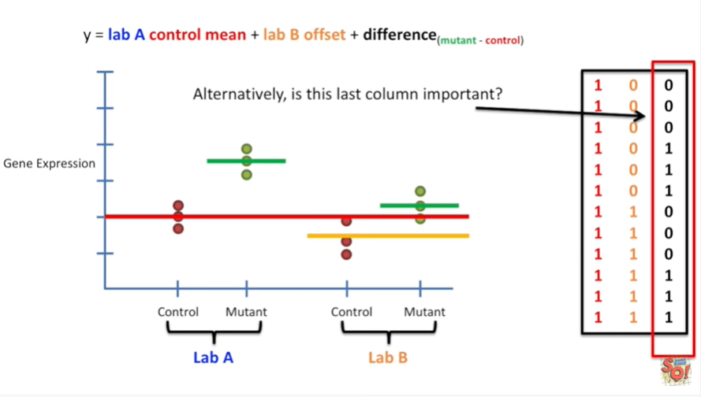

Alternatively is this last column important ?

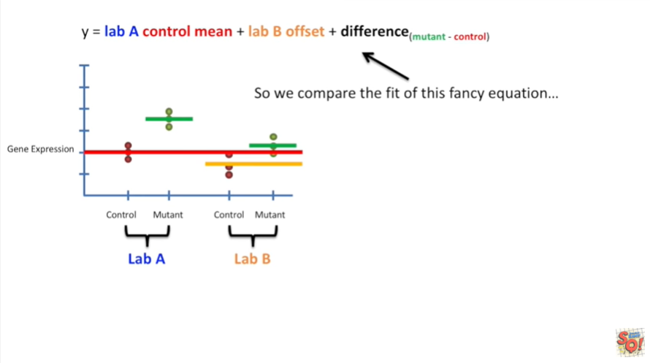

So we compare the fit of this fancy equation

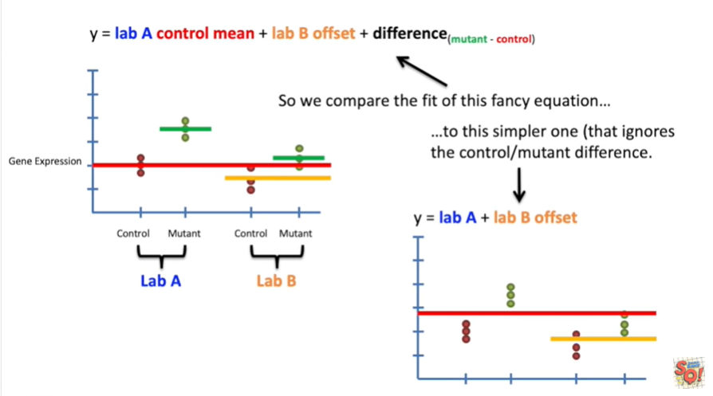

to this simpler one, that ignores the control mutant difference.

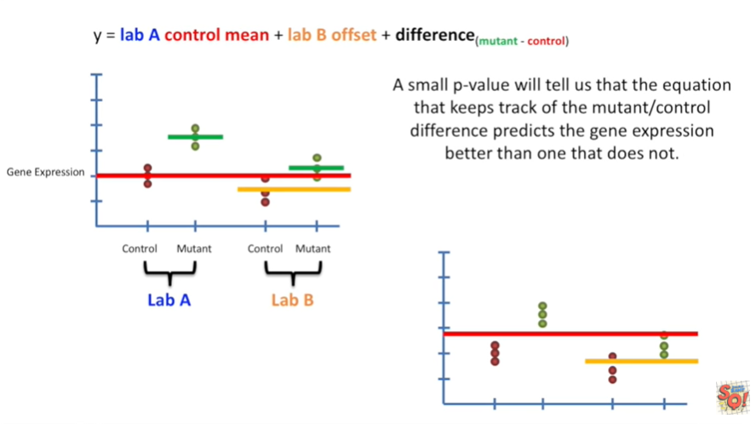

A small p-value will tell us that the equation that keeps track of the mutant control differences predicts the gene expression better than one that does not.

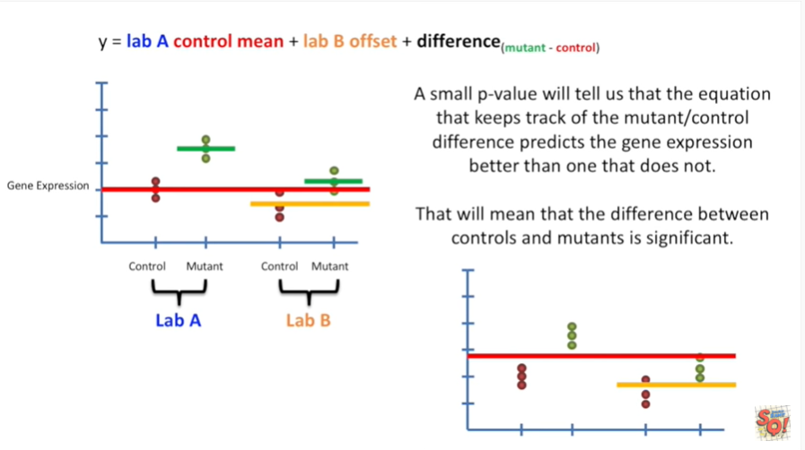

This will mean that the difference between controls and mutants is significant.